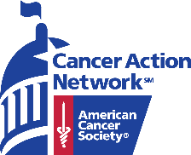
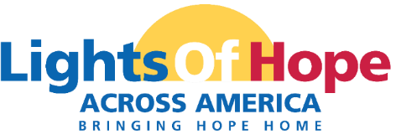
Dear NAME,
In September 2022, the American Cancer Society Cancer Action Network (ACS CAN) will host its 12th annual Lights of Hope event. Each light of hope represents a loved one’s cancer story—a survivor, someone in treatment, someone who passed from cancer, or someone who served as a caregiver.

The displays in communities across America, including one on the National Mall in Washington D.C. will send a clear and impactful message to lawmakers that fighting cancer must be a national priority – from increasing funding for lifesaving cancer research to ensuring that all Americans in all communities have access to quality, affordable cancer care.

This event is very powerful and meaningful to all. Your support will help us light hope in our local community. We invite you to support the Lights of Hope event in the following ways:

Champion Sponsor - $5,000
- Up to 500 Lights of Hope bags to be personalized
- Logo featured on four lawn signs to be displayed in your community
- Logo Recognition on ACS CAN STATE social media pages
- Opportunity for name recognition in local press release
- Opportunity to speak at local event, where applicable
- Recognized as a Corporate Sponsor in ACS CAN’s Corporate Membership Program
  - Issue briefings with ACS CAN Senior Leadership
  - Receive ACS CAN’s monthly outreach e-newsletter
  - Recognition in ACS CAN’s annual Advocacy Accomplishments report and on the ACS CAN website
Diamond Sponsor - $2,500
- Up to 250 Lights of Hope bags to be personalized
- Logo featured on three lawn signs to be displayed in your community
- Logo Recognition on ACS CAN STATE social media pages
- Recognition in ACS CAN's annual Advocacy Accomplishments Report
- Opportunity for name recognition in local press release
Platinum Sponsor - $1,000
- Up to 100 Lights of Hope bags to be personalized
- Logo featured on two lawn signs to be displayed in your community
- Logo Recognition on ACS CAN STATE social media pages
- Recognition in ACS CAN's annual Advocacy Accomplishments Report
- Opportunity for name recognition in local press release
Family Sponsor - $500
- 50 Lights of Hope bags to be personalized
- Lawn sign with one picture and family name to be displayed
- Listed as Family Sponsor on ACS CAN STATE social media

Gold Sponsor - $500
- Up to 50 Lights of Hope bags to be personalized
- Logo featured on lawn sign to be displayed in your community
- Logo Recognition on ACS CAN STATE social media pages
- Recognition in ACS CAN's annual Advocacy Accomplishments
report

Silver Sponsor - $350
- Up to 35 Lights of Hope bags to be personalized
- Name featured on lawn sign to be displayed in your community
- Name Recognition on ACS CAN STATE social media pages
- Recognition in ACS CAN's annual Advocacy Accomplishments Report
Bronze Sponsor – $200
- Up to 20 Lights of Hope bags to be personalized
- Recognition on ACS CAN STATE social media pages

Thank you for considering this request. Please contact me if you have any questions or would like additional information.
With regards,
NAME
TITLE
PERSONAL PAGE URL

