SLA Call Meeting Notes
June 2, 7:30pm ET
- Welcome, Jennie Coston, NAT Member
- Campaign Updates, Korinne Moore Berenson, Senior Director, Grassroots Campaigns
  - We expect a busy June on the funding front
    - House will be marking up their bill on Friday in subcommittee and then full committee next week
    - Senate expected in late June or after July 4
  - One way ACS CAN made a big splash for this campaign was about 10 days ago, where 25 volunteers and staff attended a Senate appropriations hearing featuring NIH director and NCI director
    - Received several shout outs and met with senators before and after
    - Video from the day: Reel by American Cancer Society Cancer Action Network - ACS CAN
  - Volunteer spotlight:
    - Ashleigh Parker, MS
        - Met with Sen. Hyde-Smith, had a good down-to-earth conversation, talking on a personal level, didn’t sense any doubt or negativity
    - Ian Padykula, SLA, SC
        - Brings cancer researcher perspective, funding for research has declined which discourages future generations of researchers
        - Spoke with NCI director, Dr. Letai for a few minutes after hearing
        - Our voices matter!
  - Cancer Votes Regional Ambassadors
    - Marcia Earle, Regional Cancer Votes Ambassador, NY
    - Regional Cancer Votes Ambassadors are here to help your state teams!
        - State Team Support
          - Join state volunteer team calls to speak about Cancer Vote
          - Assist with volunteer recruitment and onboarding
        - Cancer Votes Volunteer Support
          - Provide updates and share resources
          - Encourage engagement through activities and events
          - Answer questions
        - We are asking ALL candidates for US House and US Senate to sign the Cancer Promise. All states are important not just priority campaign states. Every candidate outreach matters because it:
          - Builds our power
          - Creates momentum
          - Strengthens accountability
        - More information on the Cancer Votes Regional Ambassadors: CV Regional Ambassador Details

- Affinity Group Updates, Mark Runyan, ACT Lead, MO
  - Happy Pride! We plan to participate in over 80 Pride events throughout this year informed by out LGBTQIA+ & Allies Engagement Affinity Group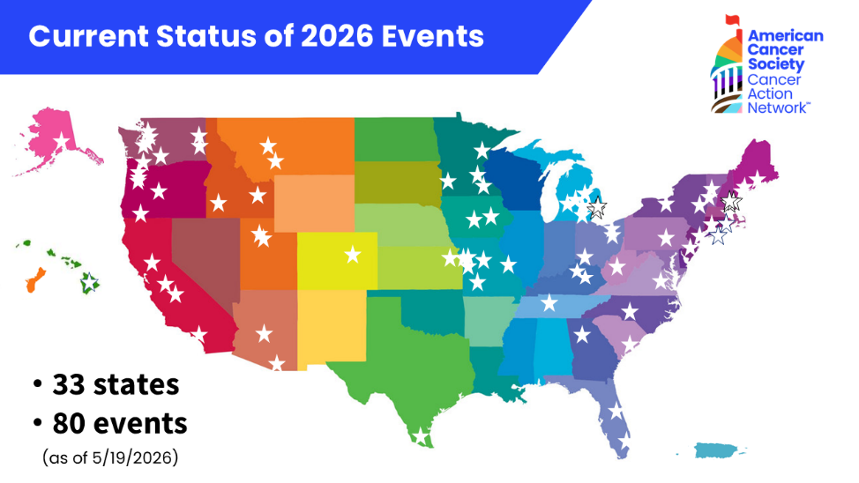
  - Reach out to your staff partner if you are interested in participating
  - In Missouri we had one of our first events, hosted by the Missouri Gay Rodeo Association during Mother’s Day weekend
    - Connected with 68 individuals and got 36 individuals to sign petition
  - To learn more about our AGs, please visit https://www.fightcancer.org/affinitygroups
- Volunteer Engagement – Rachael Eerdmans, Director, Grassroots Advocacy
  - Lights of Hope
    - Hall of Fame Call was so inspiring! Click here to view the recording:
    - We are in the middle of our Sponsorship Challenge, we have 90 sponsors already logged!
    - Register for the June 9 fundraising panel here
    - Regional LOH Competition: June 22-June 28
        - How to organize as a region- Melissa McClain, NAT Member
          - Each region will have a champion who will get in touch
          - Start strategizing and collaborating!
  - LS&LD
    - Registration is coming out later this month
    - Award nominations: start working with your team and compiling supporting info for nominations
    - CAN Opener theme has been announced: red, white, and blue (25 years of CAN and 250 years of USA)
    - Moving forward, please visit https://www.fightcancer.org/volunteer-call-schedule for notes and call recordings
- Wrap up, Moderator
  - Action items:
    - Find out if ACS CAN is participating in a Pride event in your area this summer or fall and join the effort and encourage your team to do the same!
    - Complete the on-demand Cancer Votes training and connect with your Regional Cancer Votes Ambassador- www.cancervotes.org/training.
    - Register for the June 9 LOH panel and encourage your team to join
    - Prepare for committing in the Regional LOH challenge starting June 22
    - Watch for LS&LD registration later this month.
    - Consider nominating a staff or fellow volunteer for an award

  - Next Meeting:
    - July 7, 2026

