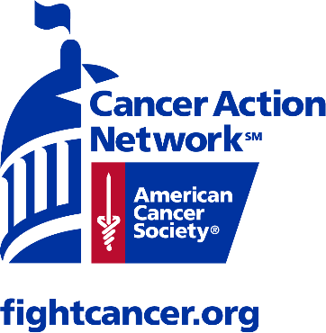

This year the American Cancer Society Cancer Action Network (ACS CAN) will be honoring those who have been touched by cancer and remembering those lost, during the Lights of Hope Across America ceremony. We are bringing hope home to every community. Everyone will have the opportunity to display Lights of Hope from their neighborhood. Lights of Hope Across America is about being creative and helping us show the world that even a pandemic will not stop our lifesaving work.
With hundreds of at home displays bearing more than 50,000 names of those touched by cancer Lights of Hope Across America will be an amazing experience. This is our opportunity to share the stores of our loved ones and to fight back against cancer. Be a part of this event by donating and having a Light of Hope bag displayed to honor your loved one.
Inset personal page URL here
