[DATE]
Dear Senator/Representative:
On behalf of the American Cancer Society Cancer Action Network (ACS CAN), I am pleased to invite you and your staff to join us for our Annual Lights of Hope event on [EVENT DATE] at [LOCATION].
Lights of Hope is ACS CAN's annual signature event that brings together cancer survivors, caregivers, advocates, and supporters from across the country to honor those whose lives have been touched by cancer and to remember those we have lost. Each light displayed represents a powerful story and serves as a visible reminder of the critical importance of continued progress in the fight against cancer.
This year's event marks the 16th anniversary of Lights of Hope and offers a meaningful opportunity for elected officials to engage with constituents and demonstrate their commitment to policies that improve cancer prevention, detection, treatment, and survivorship.
Your presence would be a meaningful demonstration of your commitment to the millions of Americans impacted by cancer while providing an opportunity to engage with your constituents here in [CITY/STATE].
Event details are as follows:
Date: [EVENT DATE]
Location: [LOCATION]
Time: [TIME]
We hope you will join us for this inspiring evening of remembrance and advocacy. If you have any questions or would like to RSVP, please contact [NAME, TITLE] at [EMAIL].
Thank you for your continued commitment to the fight against cancer. We hope you will join us.
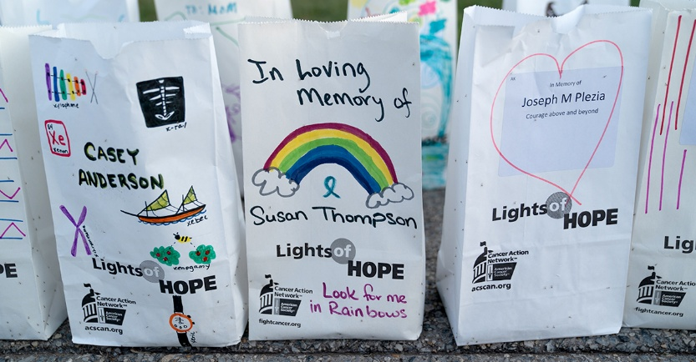
Sincerely,

Please note that the American Cancer Society Cancer Action Network (ACS CAN) is a nonpartisan organization. Accordingly, this invitation must not be treated as support by ACS CAN for your candidacy or as opposition to any opponent’s candidacy. In connection with your participation in this event, we ask that you, your staff and your volunteers help us comply with these requirements by refraining from mentioning or promoting your or anyone else’s candidacy or the election, distributing campaign literature, soliciting or receiving campaign contributions, or engaging in any activity that suggests that ACS CAN supports or opposes a candidate. For example, we ask that campaigns not use depictions of ACS CAN logos—such as those that appear on t-shirts, signs, and event banners—or photographs taken at the event. If any statement or activity appears to indicate that ACS CAN endorses a candidate, we may take steps to clarify that we did not, in fact, endorse the candidate.

