All Leads Call Notes
August 4, 7:30pm ET
August spotlight shout out:
- Becky Franks, WY: Becky is a tireless Montana advocate who has been advocating on behalf of cancer patients throughout the state for decades. She served as the executive director for cancer support community for nearly 20 years! Even though Becky has only been an ACS CAN advocate for a little over a year and a half, she has really driven our mission and work forward. She has years of policy experience and subsequently is excellent driving conversations with lawmakers in Helena and DC. Additionally, she has brought in numerous other stand out volunteers and advocates including a leading oncologist who has greatly supported our media work in the state around Medicaid. We are so grateful for Becky's tenacity, kindness, policy prowess, and general get it done attitude. We can always count on her, I don't know what Montana would do without her! Thank you Becky!
- Welcome, Tom Delleart, NAT Member

- Campaign Updates, Korinne Moore Berenson, Senior Director, Grassroots Campaigns

  - Upcoming recesses:
    - House: July 24-August 31
    - Senate: August 7-September 14
  - House Appropriations Committee marked up and voted on their Labor, Health, and Human Services bill in June
    - Positive step forward with increased funding on several fronts with room for growth
  - House also passed Continuing Resolution (CR), level funds the government through Dec 4.
  - We are optimistic to at least see a bill from Senate before recess (though unlikely going to be marked up)
  - Senate has also released their CR with funding until Dec. 11
  - Sets us up for September for both chambers to negotiate a CR
  - Keeping close eye on proposed Office of Management and Budget (OMB) ruling on grant review and management
    - Sent an email about 2 weeks ago on this issue
    - We believe research should be guided by science and not non-scientific factors
    - ACS CAN submitted comments
        - 500,000 total comments submitted with 90% opposing the proposal
    - Comments currently being reviewed but there still is a chance to delay this from taking effect by Oct. 1
    - Senator Susan Collins, Chair of Appropriations Committee is sending letter to the Administration and including a delay in implementation in the Senate CR
    - Would like to see the House follow suit when they return in Sept.
  - Clinical Trials Modernization Act (CTMA)
    - Working on building bipartisan cosponsorship in House and Senate to create momentum to move bill forward
  - Please do not schedule any in-district meetings this month as we are currently scheduling your September LS&LD meetings
  - Great time to be getting out to town hall and other events
    - Your staff partners can help you prepare questions
  - Continuing to push petition for Protect Cancer Cures, over 11,000 signatures already

- 2026 LS &LD Asks, Jeff Martin, Vice President, Grassroots Advocacy
  - Ample opportunities to workshop these asks before LS&LD
  - Support the highest possible funding increases for cancer research & prevention programs in the FY27 funding bill. ACS CAN requests:
    - $51.3 billion for the National Institutes of Health (NIH), including $7.99 billion for cancer research at the National Cancer Institute (NCI).
    - $1.5 billion for the Advanced Research Projects Agency for Health (ARPA-H).
    - $482.9 million for the Centers for Disease Control and Prevention’s (CDC) cancer programs, including $230 million for the National Breast and Cervical Cancer Early Detection Program (NBCCEDP) and $310 million for the Office on Smoking and Health.
  - Cosponsor H.R. 3521/S. 4440, the Clinical Trial Modernization Act. A bill that will reduce bureaucracy by cutting red tape, expand US innovation in research, and ensure access to cutting edge clinical trials for rural communities.
    - More info about bill and partnerships: https://www.fightcancer.org/releases/nearly-200-patient-public-health-and-health-care-professional-groups-strongly-endorse-bill
    - More Than 100 Patient and Health Care Professional Groups Express Support for Bill that Would Make It Easier for Patients to Participate in Clinical Trials | American Cancer Society Cancer Action Network

- Cancer Votes, Hannah Scott, Senior Grassroots Campaigns & Alliances Manager
  - For the first time in Cancer Votes history, over 700 volunteers trained representing all 50 states!
  - 100 candidates have already signed Cancer Promise
  - Thank you all for reaching these incredible milestones!
  - We still have 91 days until the election to get even more candidates to sign the Cancer Promise
  - Volunteer hub site with toolkits and resources: https://www.fightcancer.org/cancer-votes-volunteer-hub
    - House party toolkit: help you plan a Cancer Votes House Party to engage your friends, family, and local community in meaningful actions this election season.
    - If you need support, please do not hesitate to reach out to your staff partner or CV team
  - Bird-Dogging 101 call on Monday August 10, 8-9 pm ET/5-6 pm PT
    - RSVP for Bird-Dogging 101

- Affinity Group Updates, Anita Sloan, Idaho SLA and YLC Steering Committee
  - Black Volunteer Caucus is hosting a virtual film screening of Transforming our Legacy on Monday, August 17th at 7:30 pm ET | 4:30 pm PT
RSVP: fightcancer.org/TOLfilm
Flyer and social media image to promote

  - Pride (so far) recap
    - In partnership with Cheeky Charity, participating in 70 Pride events this year
    - 4000 people have signed the Protect Cancer Cures petition so far
    - Estimated total attendance of Pride events is 3.2 million people
  - YLC
    - Book Club Events
        - August 25, 7:30pm ET: YLC Book Club - August 2026 – Fill out form,
          - When Breath Becomes Air by Paul Kalanithi
        - October 27, 7:30pm ET: YLC Book Club - October 2026 – Fill out form
          - In His Own Time by Kathy Lemoine
    - You don’t have to read the book in entirety to join the discussion
  - ACSí Se Puede’s Virtual Open House for new Affinity Group members on Monday, October 5 at 5 pm PT / 8 pm ET
RSVP: https://forms.cloud.microsoft/r/4NSSq46Cke
  - Join us at Affinity Row at LS&LD:
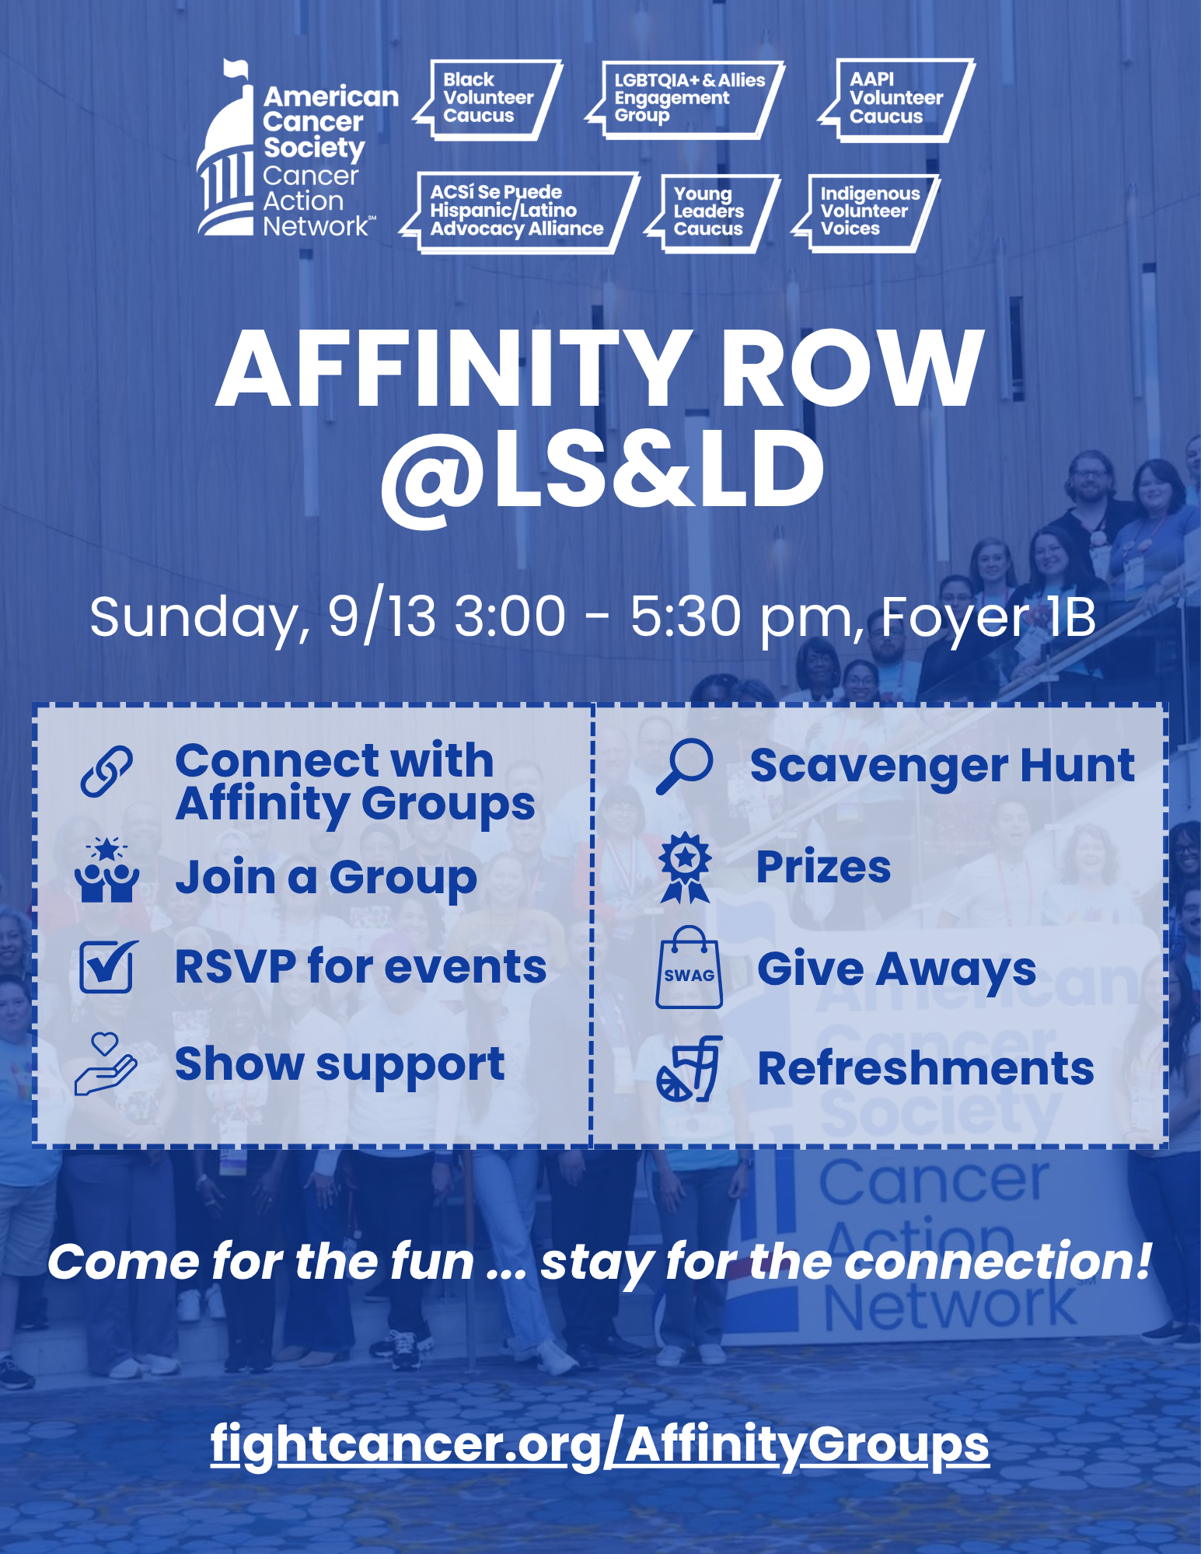

- Volunteer Engagement - Rachael Eerdmans, Director, Grassroots Advocacy
  - LS &LD
    - Travel Deadline August 10
        - Please reach out to Tracy Sun at tracy.sun@cancer.org with any questions or issues booking your travel
    - First timers call on August 20 – SAVE THE DATE
  - Lights of hope: already 50% to our goal
    - Click here to register for our next fundraising panel discussion on August 13 from 7:30-8:30pm ET /4:30-5:30pm PT
    - Next challenge is $100 in 100 hours from August 13-16
        - Social graphics: $100 in 100 Hours Lights of Hope Social Graphics | American Cancer Society Cancer Action Network
    - Upcoming deadlines
        - Aug 3: photo submissions for video inclusion
        - Sep 8: fundraising incentive deadline
        - Oct 16: DonorDrive closing deadline and LOH photo album deadline

- Wrap up, Moderator
  - Action items:
        - Sign up for the YLC Book Club
          - August 25, 7:30pm ET: YLC Book Club - August 2026 – Fill out form
          - October 27, 7:30pm ET: YLC Book Club - October 2026 – Fill out form
        - Join the August LOH panel on August 13
        - Book LS &LD Travel by August 10
        - Join the BVC’s event - Transforming Our Legacy virtual film screening on Monday, August 17th at 7:30 pm ET | 4:30 pm PT RSVP: fightcancer.org/TOLfilm
        - RSVP for Bird-Dogging 101 on Monday, August 10 at 8:00 p.m. ET / 5:00 p.m. PT. This call is hosted just for Cancer Votes volunteers and will give you clear next steps for turning candidate interactions into meaningful commitments for cancer patients, survivors, and families.
        - Missed Cancer Votes: Your Voice, Your Vote, Your Impact—or want to revisit it? Watch the recording to hear how volunteers are helping make cancer a priority this election year.
        - Ask your candidates to sign the Cancer Promise. We’ve reached an exciting milestone: 100 candidates have signed the Cancer Promise. Help us double that number! Check the list to see whether your candidates have signed, and if they haven’t, use our Email Template and Social Media Toolkit to ask them to do so. Not sure who your candidates are? Use our Candidate Lookup Tool to find out.
        - Host a Cancer Votes House Party! Use the House Party Toolkit to host a fun and impactful gathering with friends, family, or neighbors and ask candidates to prioritize cancer policies. Request a House Party Kit with gifts for you and your guests, including Cancer Votes water bottles, hats, and stickers. Need help planning? ACS CAN staff are ready to assist.
        - Get ready for LS&LD! We are not requesting any meetings during the August recess, but this month our partners are Soapbox Consulting are requesting meetings for September. What you can do is start preparing your notes and how you will deliver the asks.
        - While we are not requesting meetings while members are home in August, it's a great time to get out to any congressional town halls or events they might be hosting. (not campaign events though!) We have prepared questions you can use on our top issues - increased funding for cancer research and prevention programs, CTMA or protecting how research grants are reviewed and funded. Your staff partners can help you prepare.
        - Continue to promote our Protect Cancer Cures petition. We launched it nationwide this week, and encourage volunteers to keep sharing within their communities.
- Vaccination Policies and their impact on the cancer community, Cassandra Welch, Senior Analyst, Policy Analysis & Legislative Support and Sarah Long, Project Manager, Survey Administration and Analysis
  - Vaccination Policies and the Impact on the Cancer Community: The Important Role of Childhood Immunization
  - Overwhelming Majority of Cancer Patients and Survivors Support Broad Community Immunization and Oppose States’ Actions Limiting Access to Vaccines

