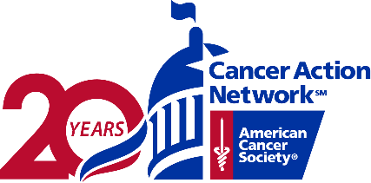
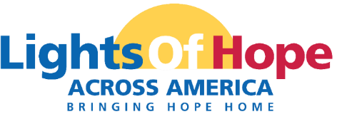
Dear NAME,
On September 18th, 2021 the American Cancer Society Cancer Action Network (ACS CAN) will host its 11th annual Lights of Hope event. Each light of hope honors loved ones who have survived cancer and remembers those we’ve lost. The displays in communities from coast to coast will send a clear and impactful message to lawmakers that fighting cancer must be a national priority – from increasing funding for lifesaving cancer research to ensuring that all Americans in all communities have access to quality, affordable cancer care.

This year’s event will culminate in a special ceremony on September 18 that will be livestreamed through Facebook and the ACS CAN website. This one-of-a-kind virtual event will also provide participants with opportunities to contact their members of Congress and share their at-home displays on social media and with fellow participants.
This event is very powerful and meaningful to all. Your support will help us light hope in our local community. We invite you to support the Lights of Hope event in the following ways:

Platinum Sponsor - $1,000
- 100 Lights of Hope bags to be personalized
- Company name listed as Platinum Sponsor on STATE webpage
- Logo featured on two lawn signs to be displayed in your community
- Logo recognition on ACS CAN STATE social media pages
- Recognition in ACS CAN’s annual Advocacy Accomplishments report
- Opportunity for name recognition in local press release
Family Sponsor - $500
- 50 Lights of Hope bags to be personalized
- Lawn sign with one picture and family name to be displayed
- Listed as Family Sponsor on ACS CAN STATE social media

Gold Sponsor - $500
- 50 Lights of Hope bags to be personalized
- Company name listed as Gold Sponsor on STATE webpage
- Logo featured on lawn sign to be displayed in your community
- Recognition on ACS CAN STATE social media pages
- Recognition in ACS CAN's annual Advocacy Accomplishments Report
Silver Sponsor - $350
- 35 Lights of Hope bags to be personalized
- Name featured on lawn sign to be displayed in your community
- Name recognition on ACS CAN STATE social media pages
- Recognition in ACS CAN's annual Advocacy Accomplishments Report
Bronze Sponsor – $200
- 20 Lights of Hope bags to be personalized
- Recognition on ACS CAN STATE social media pages
Thank you for considering this request. Please contact me if you have any questions or would like additional information.
With regards,
NAME
TITLE
PERSONAL PAGE URL

