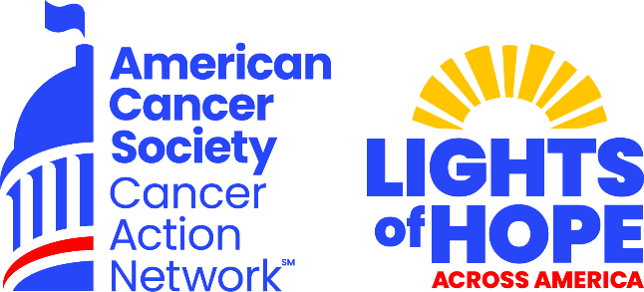

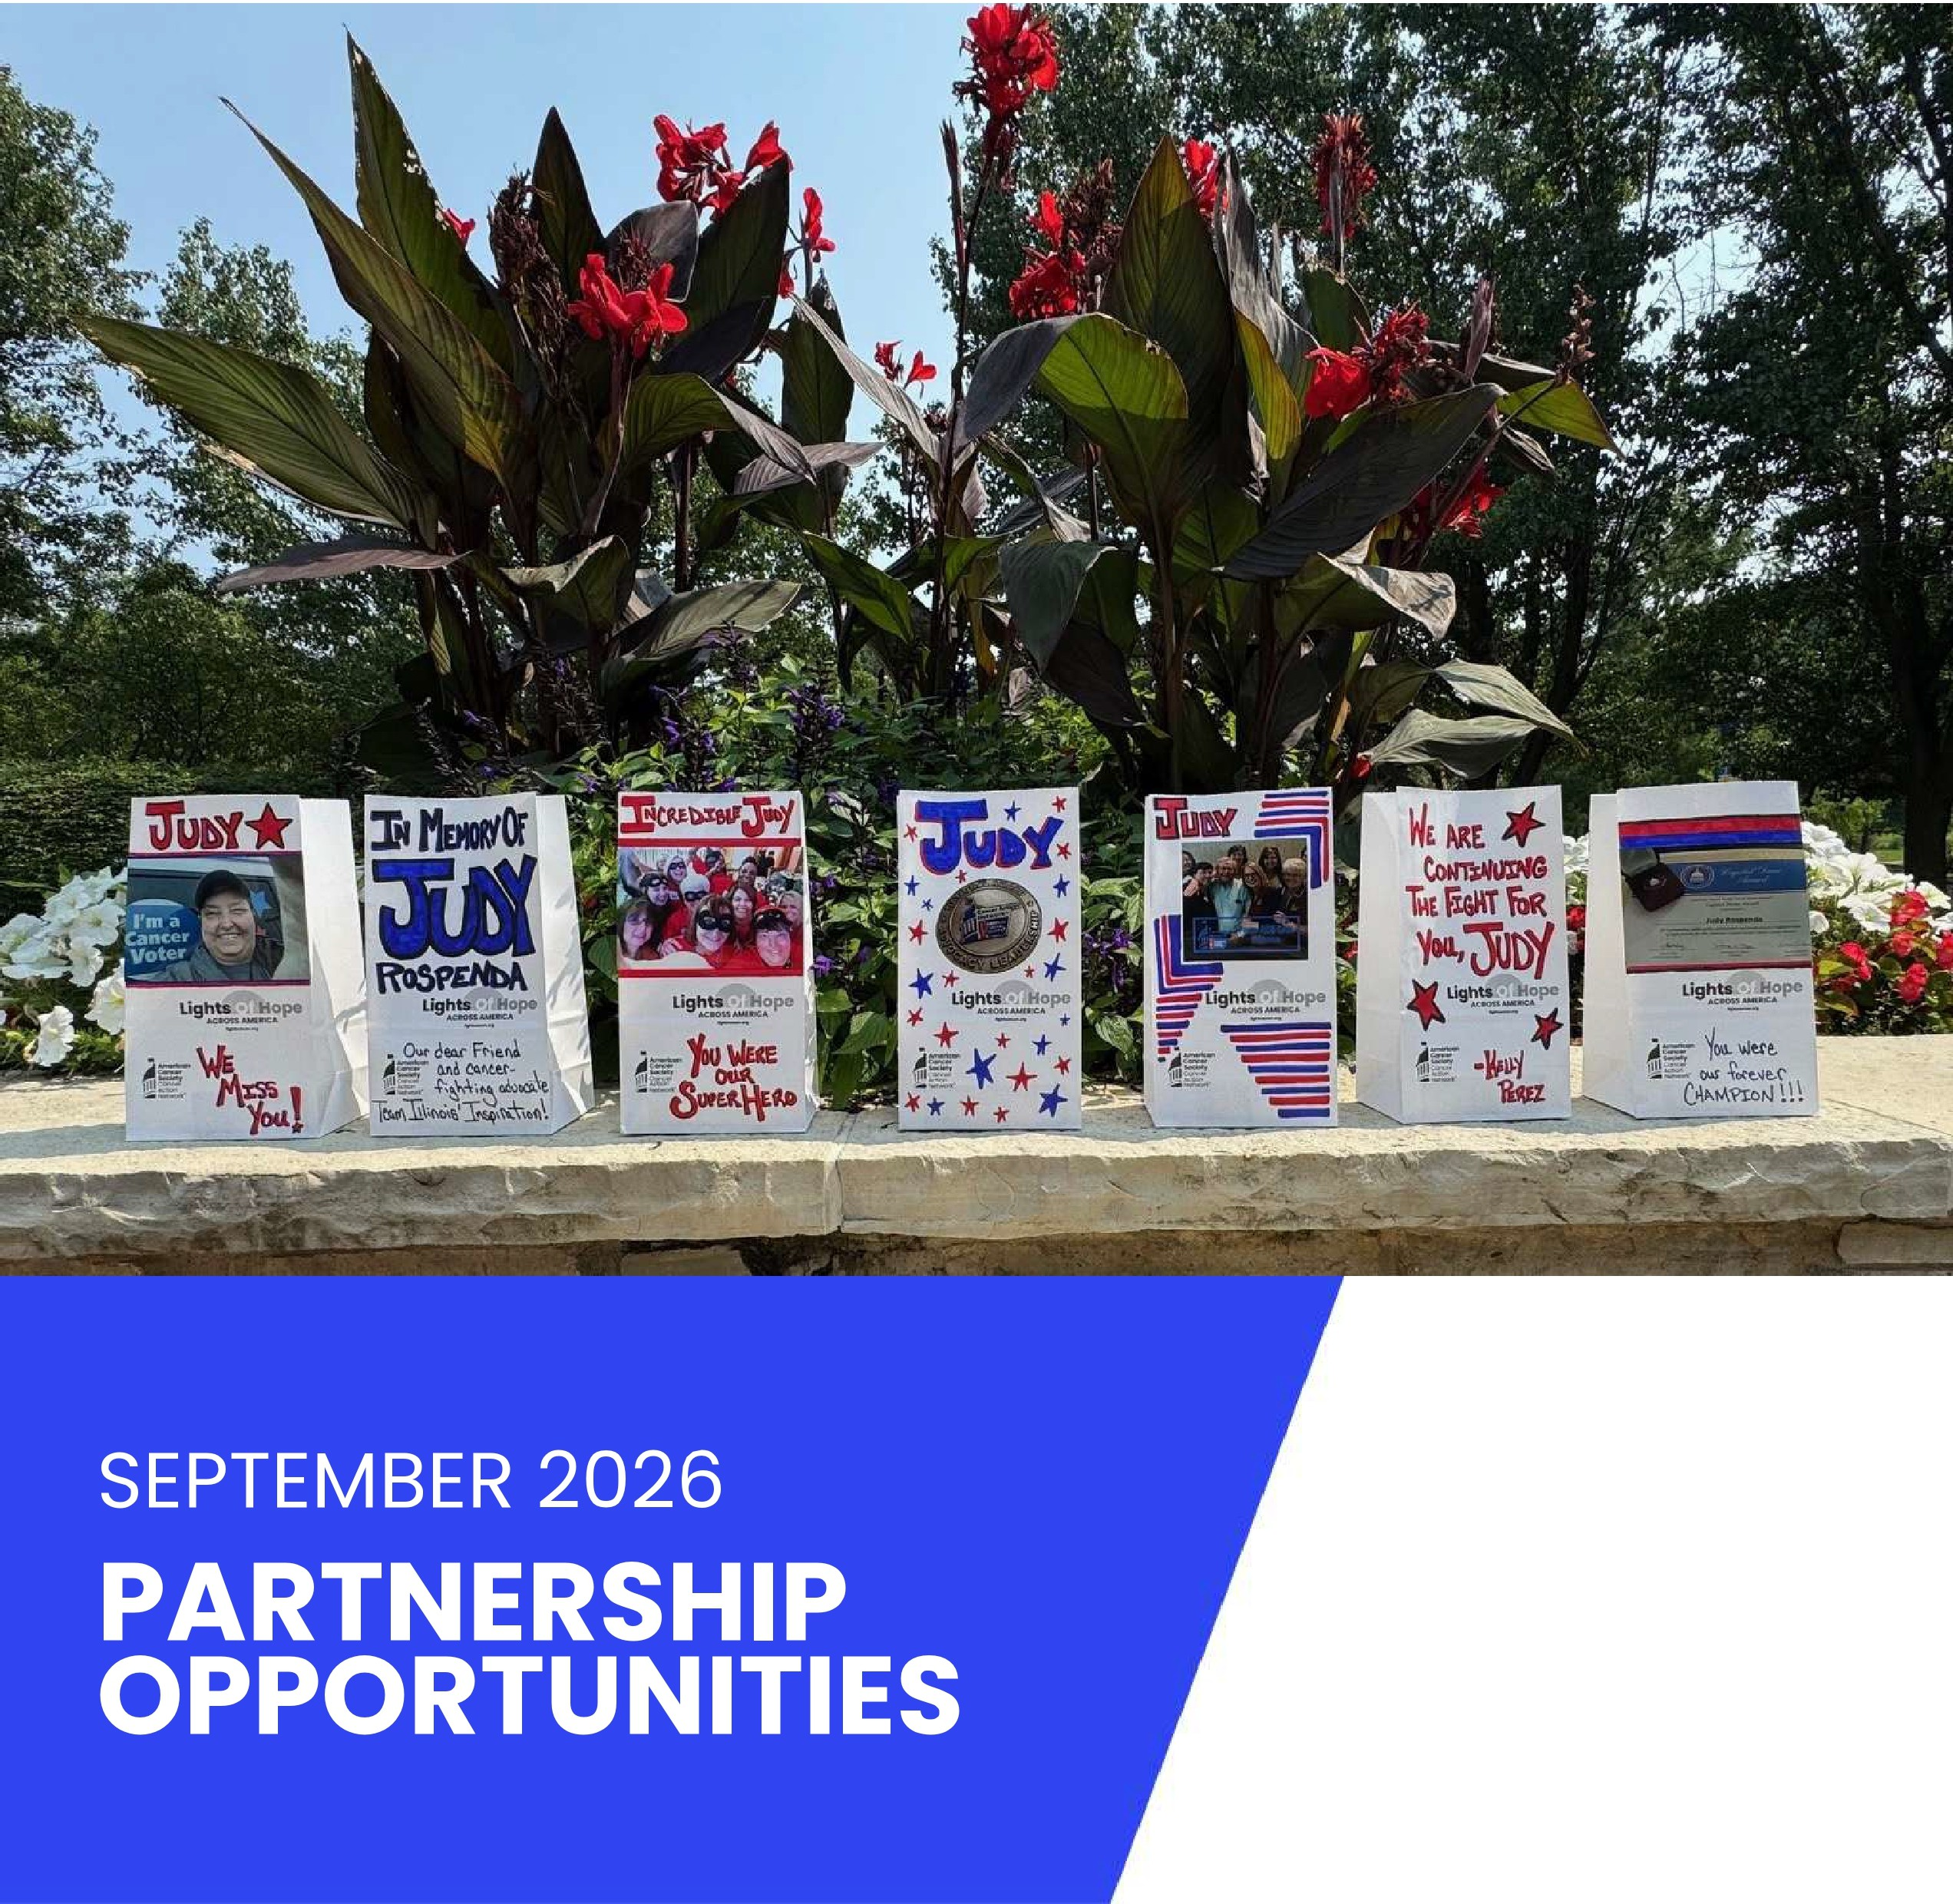

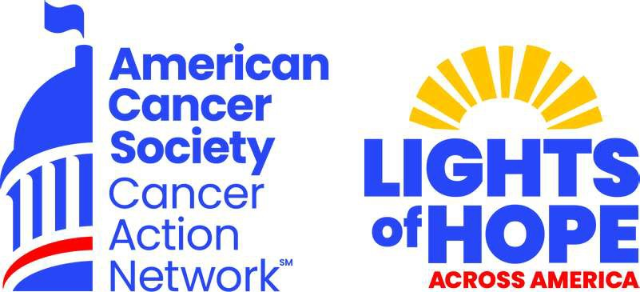
What is ACS CAN?
The American Cancer Society Cancer Action Network (ACS CAN) makes cancer a top priority for policymakers at every level of government. ACS CAN engages volunteers across the country to make their voices heard to ensure that our cities, our states and our nation adopt evidence-based policies that improve the lives of people with cancer and their families. We believe everyone should have a fair and justice opportunity to prevent, detect, treat, and survive cancer.

Since 2001, as the American Cancer Society's nonprofit, nonpartisan advocacy affiliate, ACS CAN has successfully advocated for billions of dollars in cancer research funding, expanded access to quality affordable health care, and advanced proven tobacco control measures. We stand with our volunteers, working to change public policy to end cancer as we know it for everyone.

- Medicaid Covers Us
Our Priorities
- Cancer Research Funding

- Access to Healthcare

- Cancer Prevention
- Tobacco Control

- Reducing Health Disparities

- Patient Quality of Life

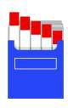


Our Impact

62.3%
of the U.S. population protected from secondhand smoke exposure by local or statewide smoke-free laws.
33%
decline in cancer death rates from 1991-2021
33.5 million
people benefited from expanded access to health insurance


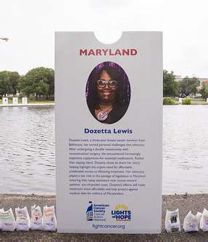

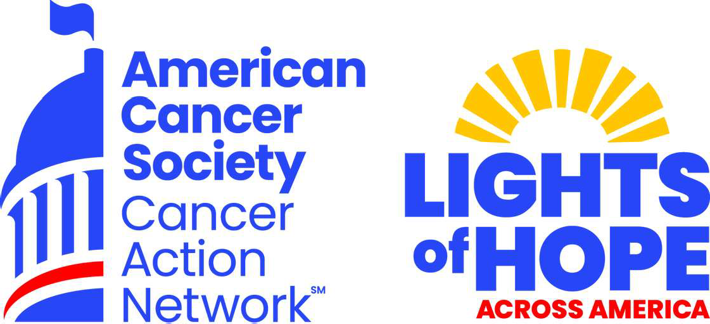


The Event
In September 2026, the American Cancer Society Cancer Action Network (ACS CAN) will host its 16th annual Lights of Hope event. Each Light of Hope honors loved ones who have survived cancer and remembers those we've lost.

The displays in communities from coast to coast and in our nation's capital will send a clear and impactful message to lawmakers that fighting cancer must be a national priority - from increasing funding for lifesaving cancer research to ensuring that all Americans in all communities have access to quality, affordable cancer care.

A look back at 2025:
- We displayed over 85,000 Lights of Hope at hundreds of at-home displays
- We raised over $934,225
- There were lk posts using #lightsofhope on our social media
- 189 television hits on Lights of Hope

This event is very powerful and meaningful to all. Your support will help us light hope across America.

We invite you to support the Lights of Hope event in the following ways:

Contributions or membership payments to the American Cancer Society Cancer Action Network, Inc are not tax deductible.
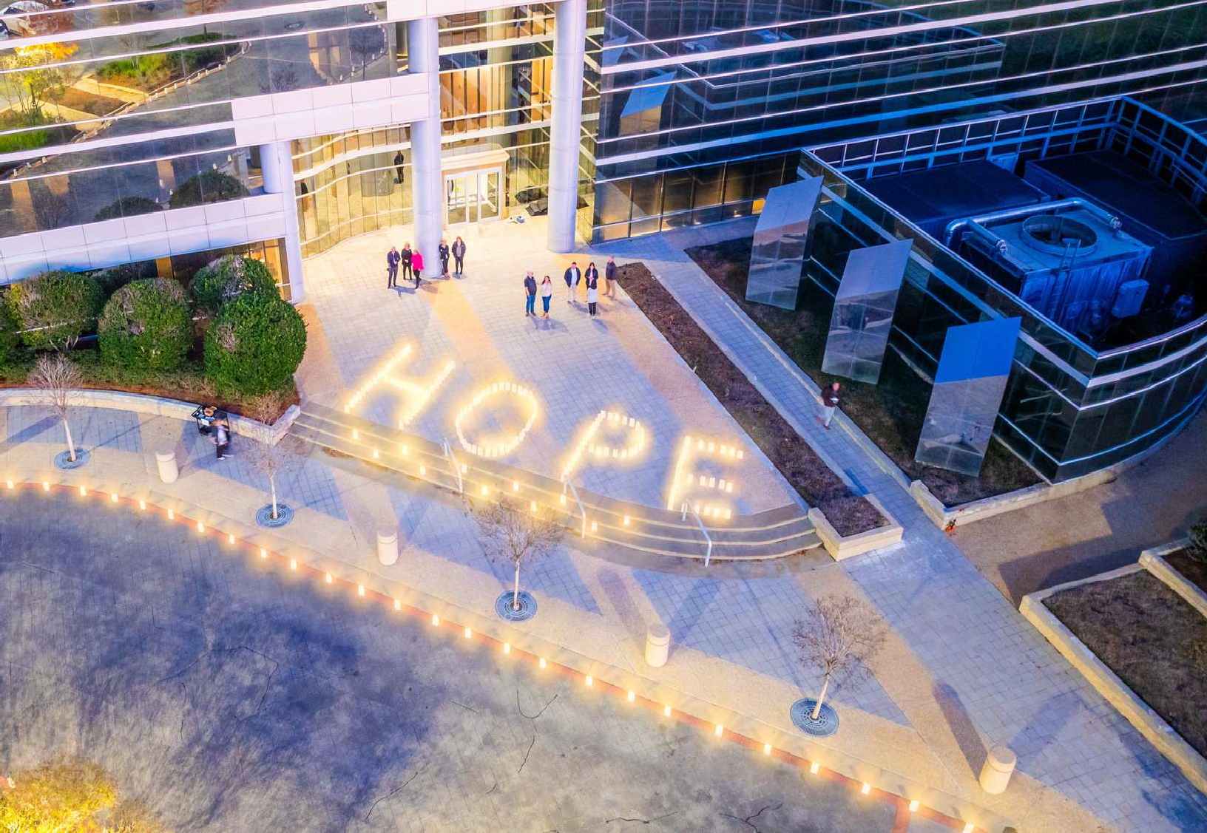
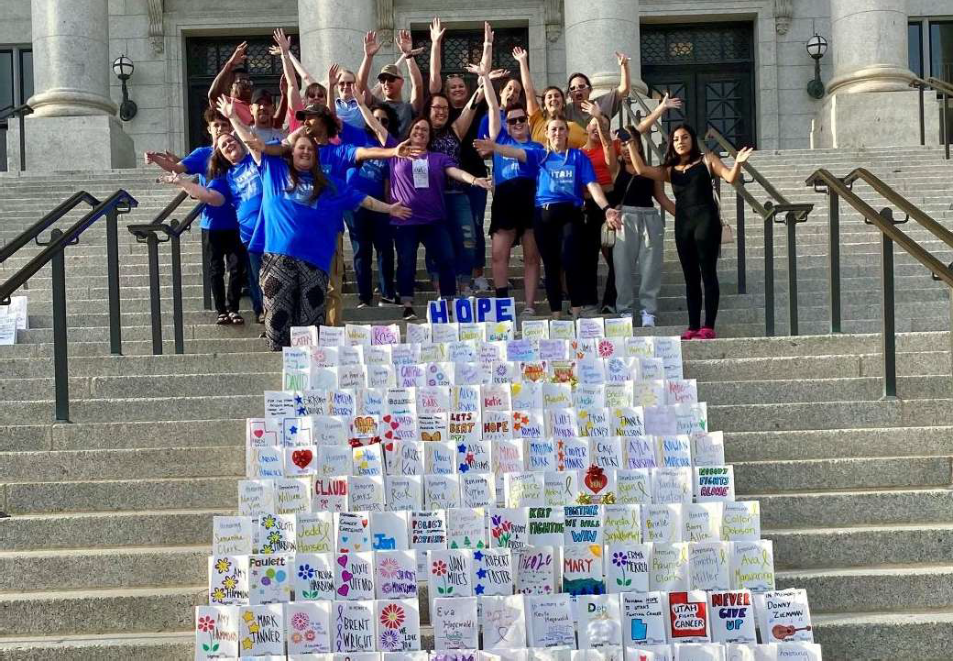
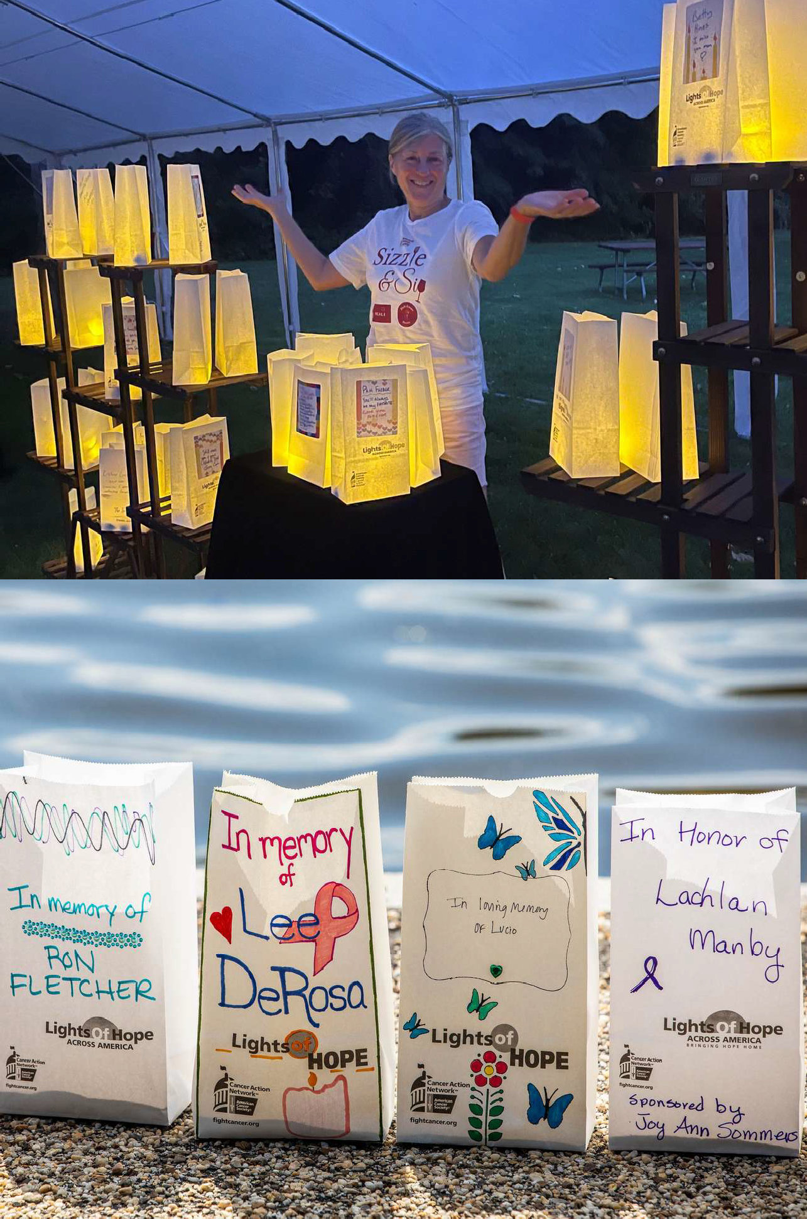
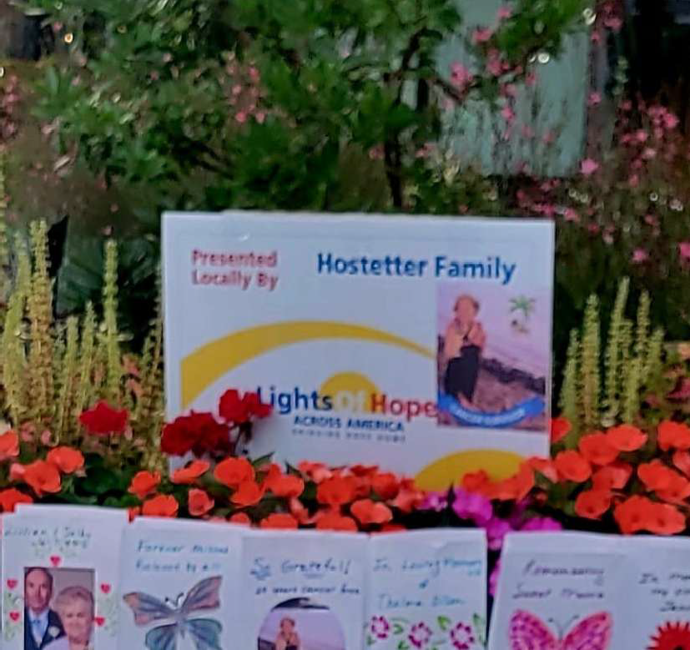
Sponsorship Opportunities
State Premier Sponsor I $10,000
  - Employee engagement through companywide Lights of Hope activation:
    - Lights of Hope bags for employees to decorate honoring those touched by cancer
    - Opportunity to launch an internal challenge where all employees receive special recognition for helping to sell Lights of Hope bags
    - Host a Lights of Hope ceremony at company headquarters or location
    - Customized lawn signs to be printed and displayed at your event
    - Access to toolkit for planning employee engagement activities
  - Premier State Sponsor logo recognition on the STATE sign at the DC display
  - Recognition on ACS CAN STATE social media pages
  - Name recognition in local press release, if applicable
  - Recognition included in video compilation shown at DC Lights of Hope display
  - Company logo featured on sponsor section of the event website
  - Recognized as a Corporate Friend in ACS CAN's Corporate Membership Program.
    - Issue briefings with ACS CAN Senior Leadership
    - Complimentary invitation to annual National Forum on the Future of Health Care in Washington, DC
    - Receive ACS CAN's monthly outreach e-newsletter
    - Recognition in ACS CAN's annual Advocacy Accomplishments report, fundraising impact report and on the ACS CAN website
Champion Sponsor I $5,000
  - Lights of Hope bags for employees to decorate honoring those touched by cancer
  - Logo featured on three lawn signs or to be displayed in your community or Lights of Hope supporter window clings to display at your business.
  - Recognition on ACS CAN STATE social media pages
  - Company name featured on sponsor section of the event website
  - Name recognition at DC Lights of Hope display
  - Name recognition in local press release, if applicable
  - Name recognition in ACS CAN's annual fundraising impact report
  - Recognized as a Corporate Sponsor in ACS CAN's Corporate Membership Program.
    - Issue briefings with ACS CAN Senior Leadership
    - Receive ACS CAN's monthly outreach e-newsletter
    - Recognition in ACS CAN's annual Advocacy Accomplishments report and on the ACS CAN website.

Sponsorship Opportunities Cont.
Diamond Sponsor I $2,500
- Lights of Hope bags for employees to decorate honoring those touched by cancer
- Logo featured on three lawn signs or to be displayed in your community or Lights of Hope supporter window clings to display at your business
- Recognition on ACS CAN STATE social media pages
- Recognition in ACS CAN's annual Advocacy Accomplishments Report
- Name recognition in local press release, if applicable
- Name recognition in ACS CAN's annual fundraising impact report
Platinum Sponsor I $1,000
- Lights of Hope bags for employees to decorate honoring those touched by cancer
- Logo featured on two lawn signs to be displayed in your community or Lights of Hope supporter window clings to display at your business.
- Logo Recognition on ACS CAN STATE social media pages
- Recognition in ACS CAN's annual Advocacy Accomplishments Report
- Name recognition in ACS CAN's annual fundraising impact report
Gold Sponsor I $500
- Lights of Hope bags for employees to decorate honoring those touched by cancer
- Logo featured on lawn sign to be displayed in your community or Lights of Hope supporter window cling to display at your business.
- Recognition on ACS CAN STATE social media pages
- Recognition in ACS CAN's annual Advocacy Accomplishments Report
- Name recognition in ACS CAN's annual fundraising impact report
SilverSponsorl$350
- Lights of Hope bags for employees to decorate honoring those touched by cancer
- Name featured on lawn sign to be displayed in your community or Lights of Hope supporter window cling to display at your business.
- Recognition on ACS CAN STATE social media pages
- Recognition in ACS CAN's annual Advocacy Accomplishments Report
- Name recognition in ACS CAN's annual fundraising impact report
Bronze Sponsor I $200
- Lights of Hope bags for employees to decorate honoring those touched by cancer
- Recognition on ACS CAN STATE social media
- Name recognition in ACS CAN's annual fundraising impact report
Family Sponsor I Starting at $350
Families can come together and sponsor your at-home event. As a family, you can place a photo of a loved one and the family name in place of a logo.

Contributions or membership payments to the American Cancer Society Cancer Action Network, Inc are not tax deductible.

