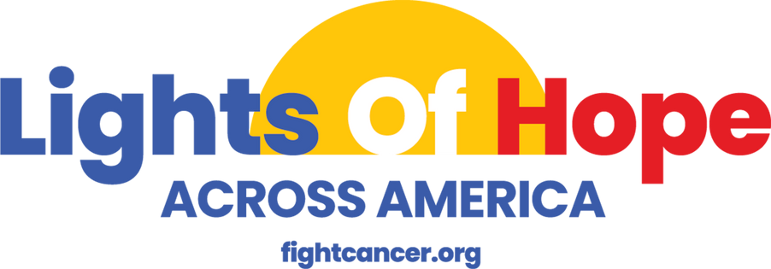

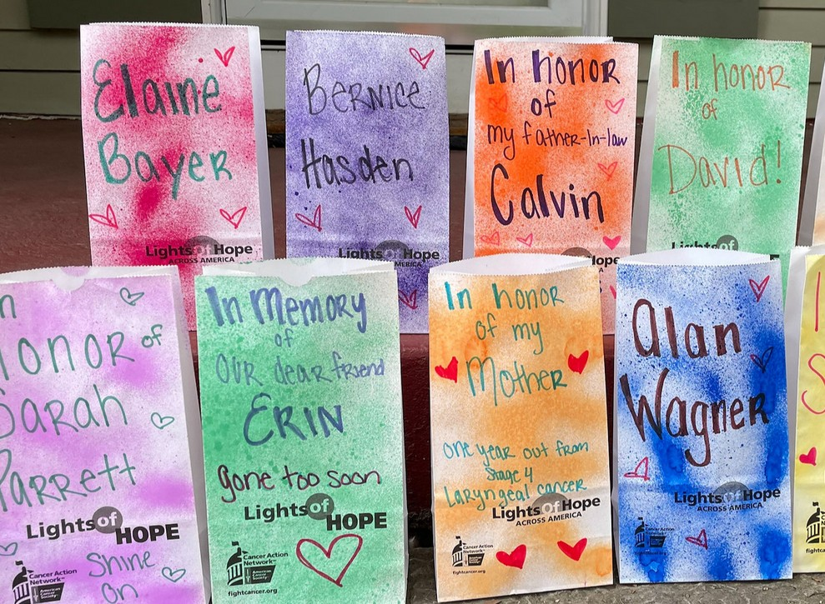
SEPTEMBER 2024

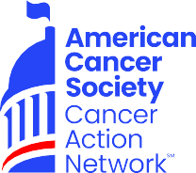
PARTNERSHIP OPPORTUNITIES

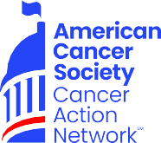
We believe everyone should have a fair and just opportunity to prevent, detect, treat, and survive cancer. Since 2001, as the American Cancer Society’s nonprofit, nonpartisan advocacy affiliate, ACS CAN has successfully advocated for billions of dollars in cancer research funding, expanded access to quality affordable health care, and advanced proven tobacco control measures. We stand with our volunteers, working to change public policy to end cancer as we know it for everyone.
What is ACS CAN?
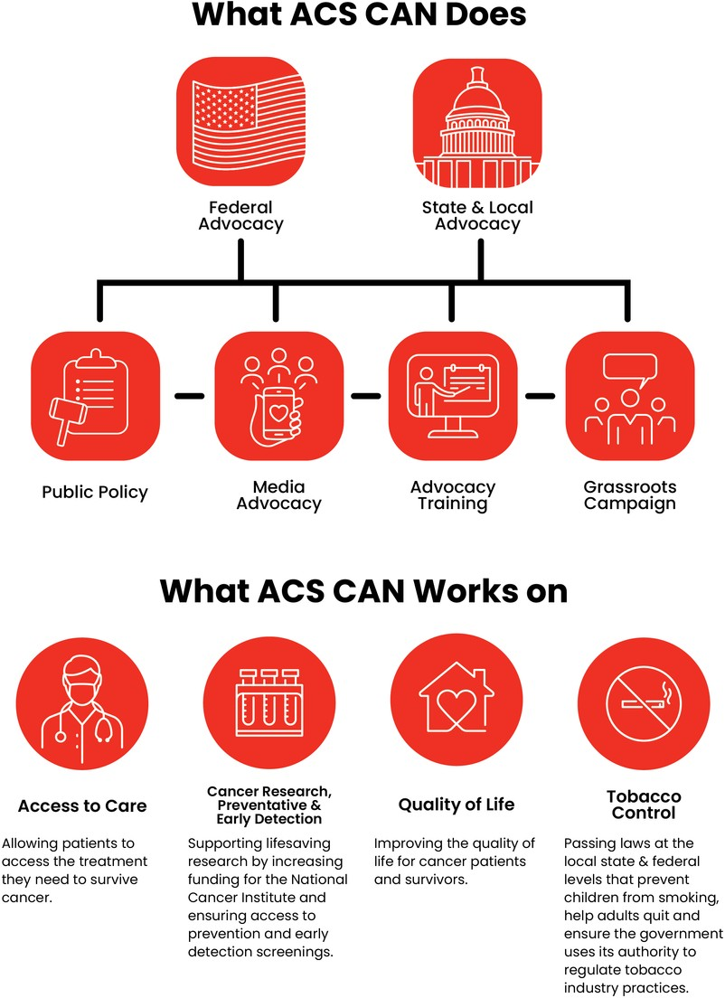

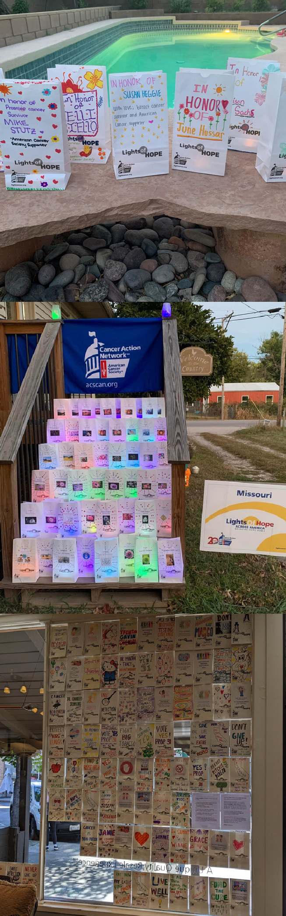

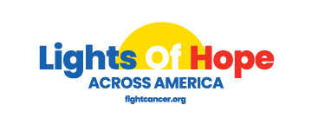
The Event

In September 2024, the American Cancer Society Cancer Action Network (ACS CAN) will host its 14th annual Lights of Hope event.

Each Light of Hope honors loved ones who have survived cancer and remembers those we’ve lost. The displays in communities from coast to coast and in our nation's capital will send a clear and impactful message to lawmakers that fighting cancer must be a national priority – from increasing funding for lifesaving cancer research to ensuring that all Americans in all communities have access to quality, affordable cancer care.

A look back at 2023:
We displayed over 70,000 Lights of Hope at hundreds of at-home displays
We raised over $868,800
2,200 public posts on Twitter and Instagram for our social media wall

This event is very powerful and meaningful to all. Your support will help us light hope across America. We invite you to support the Lights of Hope event in the following ways:

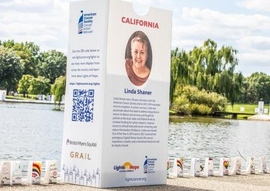
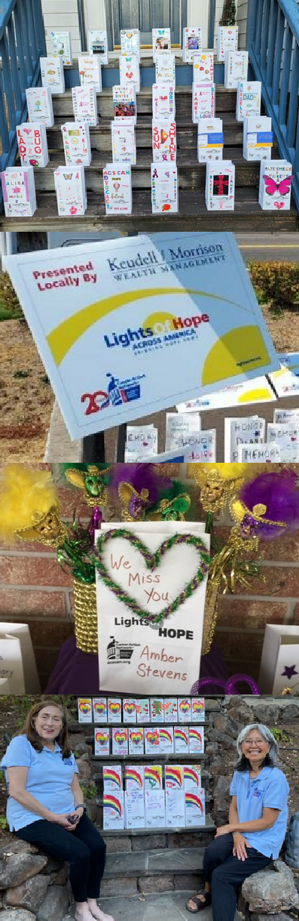

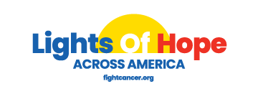
Sponsorship Opportunities

State Premier Sponsor | $10,000
Up to 250 Lights of Hope bags to be personalized at the sponsors
discretion
Logo featured on four lawn signs to be displayed across your state Logo recognition as STATE section sponsor at the DC Hope Walk Recognition on ACS CAN STATE social media pages
Opportunity for name recognition in local press release Recognition included in video compilation at DC hope walk and website
Recognized as a Corporate Friend in ACS CAN’s Corporate Membership Program.
Issue briefings with ACS CAN Senior Leadership
Complimentary invitation to annual National Forum on the Future of Health Care in Washington, DC
Receive ACS CAN’s monthly outreach e-newsletter
Recognition in ACS CAN’s annual Advocacy Accomplishments report and on the ACS CAN website

Champion Sponsor | $5,000
Up to 200 Lights of Hope bags to be personalized at the sponsors discretion
Logo featured on four lawn signs to be displayed across your state Logo Recognition on ACS CAN STATE social media pages Opportunity for name recognition in local press release Opportunity to speak at local event, where applicable
Recognized as a Corporate Sponsor in ACS CAN’s Corporate Membership Program.
Issue briefings with ACS CAN Senior Leadership Receive ACS CAN’s monthly outreach e-newsletter
Recognition in ACS CAN’s annual Advocacy Accomplishments report and on the ACS CAN website.

Diamond Sponsor | $2,500
Up to 150 Lights of Hope bags to be personalized at the sponsors discretion
Logo featured on two lawn signs to be displayed in your community Logo Recognition on ACS CAN STATE social media pages Recognition in ACS CAN's annual Advocacy Accomplishments Report Opportunity for name recognition in local press release

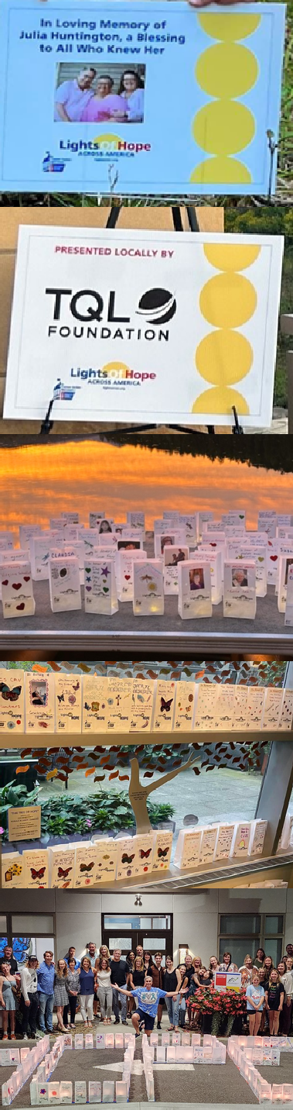
Sponsorship Opportunities Cont.

Platinum Sponsor | $1,000
Up to 100 Lights of Hope bags to be personalized
Logo featured on two lawn signs to be displayed in your community Logo Recognition on ACS CAN STATE social media pages Recognition in ACS CAN's annual Advocacy Accomplishments Report Opportunity for name recognition in local press release

Gold Sponsor | $500
Up to 50 Lights of Hope bags to be personalized
Logo featured on lawn sign to be displayed in your community Logo Recognition on ACS CAN STATE social media pages Recognition in ACS CAN's annual Advocacy Accomplishments Report

Silver Sponsor | $350
Up to 35 Lights of Hope bags to be personalized
Name featured on lawn sign to be displayed in your community Name Recognition on ACS CAN STATE social media pages Recognition in ACS CAN's annual Advocacy Accomplishments Report

Bronze Sponsor | $200
Up to 20 Lights of Hope bags to be personalized Recognition on ACS CAN STATE social media
Family Sponsor | Starting at $350
Families can come together and sponsor your at-home event. As a family, you can place a photo of a loved one and the family name in place of a logo. The family would receive the benefits at the appropriate level.

Contributions or membership payments to the American Cancer Society Cancer Action Network, Inc are not tax deductible.

