Lights of Hope 2022 Toolkit
Index
Page 2: Press release
Page 4: Letters to the Editor
Page 7: Sponsor “Thank you” Letter to the Editor
Page 8: Drop-in article
Page 9: Calendar and Event Listing
Page 11: Promoting Lights of Hope on NextDoor
Page 13: Using Patch.com to Promote ACS CAN Events and Advocacy Work

Section 1: Lights of Hope Press release
FOR MORE INFORMATION, CONTACT:
Name
American Cancer Society Cancer Action Network
Phone:
Email:
The document below could be submitted as a drop-in article via Patch (instructions on using Patch on Page 13) or sent to your editor at your local hometown paper. For questions on how to submit or help editing, please get in touch with your Regional Media Advocacy Manager.

Nationwide Event Honoring Lives Impacted by Cancer
Brings Hope Home to [CITY]
CITY, STATE – September XX, 2022 – This September, communities will honor lives affected by cancer when Lights of Hope Across America takes place on the front porches, kitchen tables and lawns of cancer patients, survivors and advocates nationwide and in Washington, DC. Resident [volunteer name] will represent [city] in the powerful national event.
1-2 sentences on personal cancer connection/story. That’s why [city] resident [volunteer name] is fundraising for Lights of Hope. So, ACS CAN may continue advocating for everyone affected by cancer, including the estimated [NUMBER OF CANCER PATIENTS IN STATE, ex: 23,300 Oregonians] who will receive a cancer diagnosis this year.
As the organization marks its 20th anniversary this year, the advocacy affiliate of the American Cancer Society is as determined as ever to ensure cancer remains a top priority for policymakers at every level of government by empowering volunteers across the country to make their voices heard to influence public policy change that saves lives in (city) and nationwide.
“Every year, Lights of Hope sends an important message to lawmakers that we need their support in the fight against cancer. This year’s message is as important as ever,” said [NAME]. “Throughout the pandemic, cancer hasn’t stopped and neither have we. As we continue to emerge from the worst of it, I look forward to getting my neighbors, family members and friends in [TOWN/CITY] involved in this heartfelt event to honor and remember our loved ones and their cancer fight, as well as remind everyone of the pandemic’s impact on cancer patients/survivors/caregivers like myself / cancer patients and their families.”
[IF APPLICABLE: DETAILS ABOUT YOUR PERSONAL LOH DISPLAY – What is your plan? If not, delete.]
For details on how to dedicate a Lights of Hope bag, please contact [volunteer name] at [email, phone] or visit (LOH page).
###

About ACS CAN at 20
The American Cancer Society Cancer Action Network (ACS CAN) makes cancer a top priority for policymakers at every level of government. ACS CAN empowers volunteers across the country to make their voices heard to influence evidence-based public policy change that saves lives. We believe everyone should have a fair and just opportunity to prevent, find, treat, and survive cancer. Since 2001, as the American Cancer Society’s nonprofit, nonpartisan advocacy affiliate, ACS CAN has successfully advocated for billions of dollars in cancer research funding, expanded access to quality affordable health care, and made workplaces, including restaurants and bars, smoke-free. As we mark our 20th anniversary, we’re more determined than ever to stand together with our volunteers and save more lives from cancer. Join the fight by visiting www.fightcancer.org.

Section 2: Lights of Hope Across America Letters to the Editor
Don’t forget to reference the “Submitting Your LOH LTE” document also found in this toolkit before submitting your letter. The tips and tricks on the sheet will guide on the submission process and put you in the best position for your letter to be published. Need help editing or guidance on how to best submit to your local paper? Contact your Media Advocacy Manager for more information.

With personal story and LOH details
LTE #1
Word count: 137 words
To the editor,
1-2 sentences on personal cancer story/cancer. This September, I’ll be honoring/remembering my loved ones during Lights of Hope Across America. This heartfelt event features thousands of lit bags decorated with the names of people who’ve fought cancer as a powerful message of hope.
The American Cancer Society Cancer Action Network is hosting hundreds of ceremonies across the country in addition to Hope Walk in Washington, D.C. on September 13, 2022. More than 50,000 bags will be displayed on front porches, backyards and parks in communities across the country, including Washington, D.C.
Your contribution will help me honor those fighting cancer and remember those lost to the devastating disease—while supporting ongoing efforts to fight cancer in (state). To dedicate a bag, contact (Name) and (EMAIL) or visit (LOH web page).
Sincerely,
Name
Hometown
With personal story and LOH details
LTE #2
Word count: 191 words
To the editor,
Every day volunteers like me with the American Cancer Society Cancer Action Network (ACS CAN) continue our lifesaving work to fight cancer through public policy, particularly after what’s been an especially difficult two years for cancer patients/survivors like myself (remove ‘like myself’ if not applicable) and our/their families.
1-2 sentences on personal cancer connection. If cancer has also touched your life, you can make a difference through ACS CAN’s Lights of Hope Across America—an annual, moving tribute to fight back against cancer. This year, volunteers will again illuminate their neighborhoods in September with lit bags featuring the names and photos of cancer survivors and those we’ve lost to cancer.
This is a great opportunity for (TOWN/CITY) to participate in this heartfelt event.
To learn more about how to dedicate a bag and display it in your neighborhood, visit insert website or call insert phone number.
Sincerely,
Name
Hometown
Without personal story
LTE #3
Word count: 222 words
To the editor,
As (state) residents feel hopeful as our country continues to emerge from the pandemic, I’m calling on readers to join me in bringing those same positive feelings to cancer patients and their families. I, for one, have been continually inspired by the work of the American Cancer Society Cancer Action Network in the fight against cancer for its last 20 years and every day throughout the pandemic.
I’m grateful for their dedication to fight for others and the opportunity to support their continued work.
Each year, ACS CAN holds its annual Lights of Hope Across America ceremony to honor and remember those touched by cancer through a tribute with thousands of lit bags featuring the names of loved ones and their cancer story. The event is being held on front porches, lawns and more across the country, including here in (city) and has reiterated the importance of their lifesaving work.
More than 50,000 bags will be displayed across America in September
Let’s show the world that even through a pandemic, cancer doesn’t stop, so neither can we. To dedicate a Lights of Hope bag, visit (website) or call (number).
Sincerely,
Name
Hometown
General
LTE #4
Word count: 162 words
To the editor,
Cancer hasn’t stopped through this pandemic, so I won’t stop fighting for a cure. Amid this unprecedented pandemic, cancer patients and survivors need help more than ever. Have you or a loved one been impacted by cancer? There’s an easy way to make a difference. This September, I’ll be participating in the American Cancer Society Cancer Action Network’s Lights of Hope Across America to fight back against cancer, especially after what’s been a difficult few years for patients and their families. This year is an opportunity to reflect on those impacts, honor cancer survivors and remember those lost to cancer by decorating a lit bag with their name and showcasing them in our homes and communities.
More than 50,000 Lights of Hope bags will be displayed nationwide. I want to make sure that (CITY/TOWN) is represented.
Please add your name and story to a Lights of Hope bag to help our fight. You can purchase a bag at (website) or by calling (phone number).
Sincerely,
Name
Hometown
General
LTE #5
Word count: 213 words
To the editor,
Every American has faced uncertain and challenging times through the pandemic. The stakes have been even higher for the [Iowans, Hoosiers, etc.] diagnosed with cancer in the past two years.
Cancer patients, their families and caregivers need to know we’re still here for them – that the American Cancer Society Cancer Action Network and its volunteers haven’t stopped advocating for critical research funds and access to health care. I’m proud to have a visible way to raise awareness for cancer and a way to bring hope as we continue to emerge from the pandemic.
ACS CAN’s annual Lights of Hope ceremonies display thousands of lit bags decorated with the names of cancer survivors and those lost to the disease. Volunteers will showcase Lights of Hope on our front porches, kitchen tables and front lawns as we bring hope home to communities around the nation. I look forward to displaying Lights of Hope bags right here in {TOWN/CITY} and bringing this powerful ceremony to our backyard.
If anyone would like to get a Lights of Hope bag, please contact me: [EMAIL ADDRESS OR PHONE]. The bags may also be ordered at (insert personal LOH page).
Sincerely,
NAME
HOMETOWN

Section 3: Lights of Hope Sponsor “Thank you” LTE

Submit this LTE to thank a sponsor. You can also include more than one sponsor in the same letter, assuming they are covered by the same newspaper.

LTE #1 – (Thanking a Sponsor)
Word count: 234 words

To the editor,

Every day, the American Cancer Society Cancer Action Network (ACS CAN), alongside volunteers like myself, has continued our lifesaving work to fight cancer through public policy.

[Short personal story, ex: “My husband is a cancer survivor, diagnosed a year before we were married”]. This experience compelled me to join the ACS CAN team and further their lifesaving mission. At a critical juncture in the fight against the disease today, the importance of such work is reiterated, while my resolve for a world free from cancer is as firm as ever.

I’m not alone in this. Generous organizations are stepping up to help ACS CAN as we reflect on the past year’s impacts on cancer. I want to thank [Business] of [Town] for recently sponsoring ACS CAN’s Lights of Hope Across America event.

Thanks to [business name]’s generous support, hundreds of lights of hope bags will be displayed across [city or state] to honor cancer patients and survivors, and ACS CAN is armed with additional resources to advocate for cancer research funding, access to healthcare and other priorities.

You can help us make a difference. If you or your business would like to help fund the fight against cancer, please contact [e-mail] or visit [fundraising site] to donate.

Sincerely,

Name
Town
Contact Info

Section 4: Lights of Hope Drop-in Article

The document below could be submitted as a drop-in article via Patch or sent to your editor at your local hometown paper. For questions on how to submit or help editing, please get in touch with your Regional Media Advocacy Manager.
Help Fight Cancer in Your Community with Lights of Hope
Imagine hundreds of colorful lit bags, each decorated with the name of a loved one and their cancer story. Now imagine these displayed at the Constitution Gardens in Washington, D.C. and homes and neighborhoods across the country—including yours.
Each year, the American Cancer Society Cancer Action Network hosts its Lights of Hope event as a powerful tribute to remember loved ones we have lost to cancer and celebrate the millions of cancer survivors. This year, [town/city] residents are invited to participate.
In September, hundreds of ACS CAN cancer advocates and their friends and families will unite for the 12th annual Lights of Hope. More than 50,000 bags will be displayed in Washington, D.C. and on front porches, backyards and kitchen tables in all 50 states.
The community can get involved here in [town] by [Insert local details about your Lights of Hope plans and display.]
“Throughout the pandemic, cancer hasn’t stopped and neither have we. But we can’t fight cancer alone, and Lights of Hope sends a visual reminder to our lawmakers that they must do more to help save lives from this horrible disease,” said [Name] of [Town]. “It’s an incredibly moving event and a great way to honor and remember those impacted by cancer. I look forward to getting my friends, family and community involved.”
This year’s Lights of Hope event coincides with the 20th anniversary of ACS CAN. As the advocacy affiliate of the American Cancer Society, the organization works to ensure cancer is a top priority for policymakers at every level of government. ACS CAN empowers volunteers across the country to make their voices heard to influence public policy change that saves lives from cancer in [city] and nationwide.
If cancer has touched your life, you can sign up to participate in Lights of Hope atwww.fightcancer.org/hope. Anyone interested in donating for a bag to recognize a loved one should contact [Name] and [contact information] or visit [LOH page.]
###

Section 5: Calendar and Event Listing

NOTE: Please work with your Grassroots Manager and Media Advocacy Manager if you want to invite local media to your LOH display to make sure it follows our guidelines.

This template should be used strictly for calendar/event postings. You can submit this to your local Patch.com event section, NextDoor or the “Calendar of Events” in your local newspaper.

Moving Tribute for [TOWN] Cancer Patients and Survivors on (DAY OF THE WEEK) As Part of the National Lights of Hope Across America

The American Cancer Society Cancer Action Network (ACS CAN) hosts its annual Lights of Hope event, a powerful tribute to honor and remember loved ones impacted by cancer. This year, the organization celebrates its 12th anniversary of the moving event that will feature 50,000 lit bags displayed in Washington, DC, and neighborhoods throughout the country, including right here in [TOWN].

WHAT: Lights of Hope Across America is a powerful display of more than 50,000 lit bags to honor and remember loved ones with cancer and serve as a reminder to (state) and national lawmakers on the importance of ensuring the fight against cancer remains a top priority. If relevant: Insert a sentence about your local activity/display.

WHEN: DAY, September ##, 2022 at TIME.

WHERE: LOCATION FOR YOUR LOCAL DISPLAY/ACTIVITY. Insert COVID-19 guidelines for your city and state, if applicable.

WHY: This year’s Lights of Hope Across America event coincides with the 20th anniversary of ACS CAN. As the advocacy affiliate of the American Cancer Society, the organization works to ensure cancer is a top priority for policymakers at every level of government. ACS CAN empowers volunteers across the country to make their voices heard to influence policy change that saves lives from cancer in [city] and nationwide.

HOW: Visit: www.fightcancer.org/hope. To donate a Lights of Hope bag, contact [Name] at [Email/phone?] or visit [PERSONAL LOH PAGE].

###

About ACS CAN at 20
The American Cancer Society Cancer Action Network (ACS CAN) makes cancer a top priority for policymakers at every level of government. ACS CAN empowers volunteers across the country to make their voices heard to influence evidence-based public policy change that saves lives. We believe everyone should have a fair and just opportunity to prevent, find, treat, and survive cancer. Since 2001, as the American Cancer Society’s nonprofit, nonpartisan advocacy affiliate, ACS CAN has successfully advocated for billions of dollars in cancer research funding, expanded access to quality affordable health care, and made workplaces, including restaurants and bars, smoke-free. As we mark our 20th anniversary, we’re more determined than ever to stand together with our volunteers and save more lives from cancer. Join the fight by visiting www.fightcancer.org.

Section 6: Promoting Lights of Hope on NextDoor
You can use any of the templates shared above to personalize and promote your event or fundraising efforts on NextDoor.com.
Use NextDoor.com to Promote Your Lights of Hope Fundraiser or Local Display
What is NextDoor? NextDoor is both a phone application (NextDoor) and website (NextDoor.com) where you can instantly connect with others in your neighborhood to share relevant news and information – including promoting your Lights of Hope fundraiser or local display—exchange recommendations, receive updates from public agencies, borrow tools, sell couches and more.
Why use it? NextDoor has been successful as one of the only social media platforms that is centered on the hyperlocal connection. As such, what better way to invite new neighbors to donate to your Lights of Hope fundraiser or share in your local Lights of Hope display?
Below you’ll find clear instructions on how to share information and/or post an event including templates you can easily modify to fit your needs.
Questions? Don’t hesitate to ask your Media Advocacy partner for help. The ACS CAN team is available to review anything you create before posting. We can also provide logos and photos for you to post with your article or event.
------------------------------------------------------------------------------------------------------------------------------
Create Your Account
- Click “Sign Up” or the green “Join your neighborhood” button on mobile. 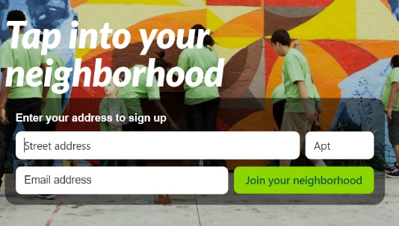
- Enter information as requested. Don’t worry about entering your street address, NextDoor will only show your street name to neighbors, not your full address.
Share Your Fundraiser
- Click “post a message, event, poll or alert to your neighborhood” at the top middle of the webpage (green pen and notepad icon on the right for mobile users).
- “Message” should be highlighted and “general” selected from the category drop-down menu.
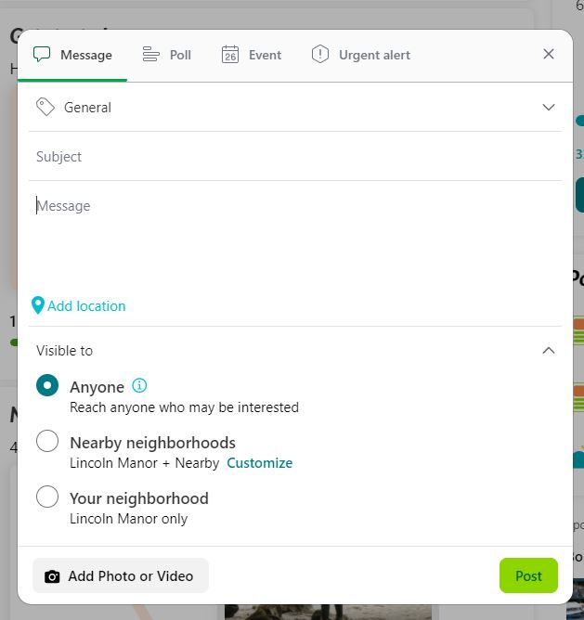
- Fill in the subject and message boxes.
- Add a photo or video and click the green “Post” button. Your post is ready for your fellow neighbors (or anyone that is interested to see!)
------------------------------------------------------------------------------------------------------------------------------
Share Your Local Display
- Follow the same instructions as above, but make sure “Event” is highlighted and “Fundraisers” selected from the category drop-down menu.
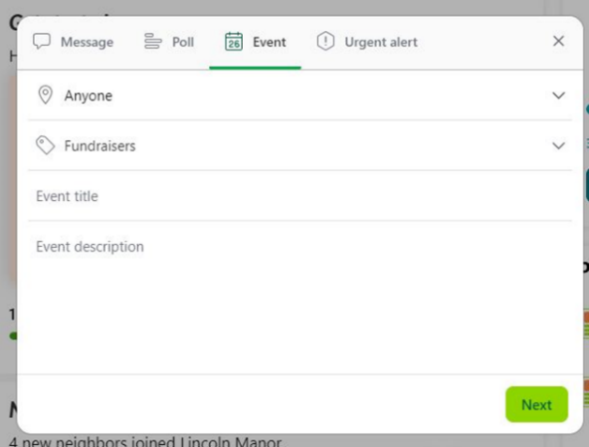
- Fill in your event title, description and add the correct time and date on the next screens accordingly.
- Check “Add to public event calendar” (“viewable by all NextDoor members” on mobile) and “Announce to neighbors”

Section 7: Using Patch.com to Promote your ACS CAN Advocacy Work and Lights of Hope Events
You can use any of the templates shared above to personalize and promote your event or fundraising efforts on Patch.com.

What is Patch.com? Patch is an independent local news platform, operating in over a thousand locations across the country. It’s community-specific news and event information. Patch welcomes and encourages community members to post directly to the site.
Why use it? Across the country, local news is going digital. Patch gives you an opportunity to share your voice and ACS CAN’s mission in your community. You can publish stories about your advocacy work or promote fundraising events in your community, for free! Your Grassroots or Media Advocacy partner can often provide you a press release template that you can modify to fit your needs, making it easy to copy and paste to create a story.
How? Ask your Grassroots or Media Advocacy partner for a template press release about an event like Lights of Hope or advocacy ask. Or, take a hand at crafting your own material and share with your ACS CAN staff partner for review/feedback before posting.
When? The possibilities are endless. Share your Lights of Hope fundraising event. Drop in ACS CAN’s templated press release about your attendance at Leadership Summit and Lobby Day. Share an article about that great volunteer award you just won (and don’t forget a photo!)
What next?
- Share, share, share! Let your Grassroots and/or Media Advocacy partner know that your story posted.
- Share the link on your own social media page using campaign hashtags; ACS CAN will share from our pages, too.
- Log your action in the Ambassador Action Center & keep up the great work!
Questions? Don’t hesitate to ask your Grassroots or Media Advocacy partner for help. The ACS CAN team can provide samples of past articles or template press releases, and we are available to review anything you create before posting. We can also provide logos and photos to post with your article or event.

New Users: How do I make a Patch account?
- Go to patch.com/register or click "Sign up" in the top right corner of Patch.com
- Enter your town or zip code and select your nearest Patch site from the drop-down menu
Great – you have an account! To post an article:
- Go to my.patch.com/start
- Click “Write an Article”
- Select where you would like your article to appear within your home Patch
- Write a headline for your article – 65 characters or less. Keep it concise!
- Write a subheadline. What’s a quick summary of what your article is about?
- Choose an image for your article if you’d like. If you don’t have an image, we can provide you with an ACS CAN logo or graphic, just ask!
- Write your article – or copy and paste your personalized press release template.
- You can either save your post as a draft (this allows you to come back to it later if you want to add more) or post it right away. Currently, there is no way to preview your article before you post but luckily you can always go back and edit your article as much as you’d like.
To post an event:
- Click on the "Post an Event" icon.
- Choose your Patch: Enter your town name or zip code
- Enter an event title that describes what the event is; add event date and time
- Add an eye-catching photo. If you don’t have an image, we can provide you with an ACS CAN logo or graphic associated with the campaign you’re promoting, just ask!
- Share details about the event and specific info the public should know
- Write the event address in the specific fields
- Include a website that users can go to for more information about the event
- Click "Post Now" and see your event on the Patch calendar.

