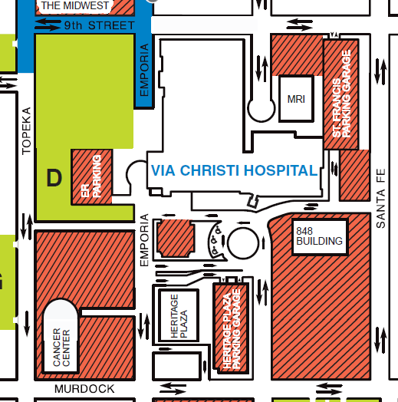

Please park in the parking garage and take the garage elevator to floor 2. The hallway will lead you into the hospital.

The Guadalupe Conference room in located on the north end of the employee cafeteria.

See next map