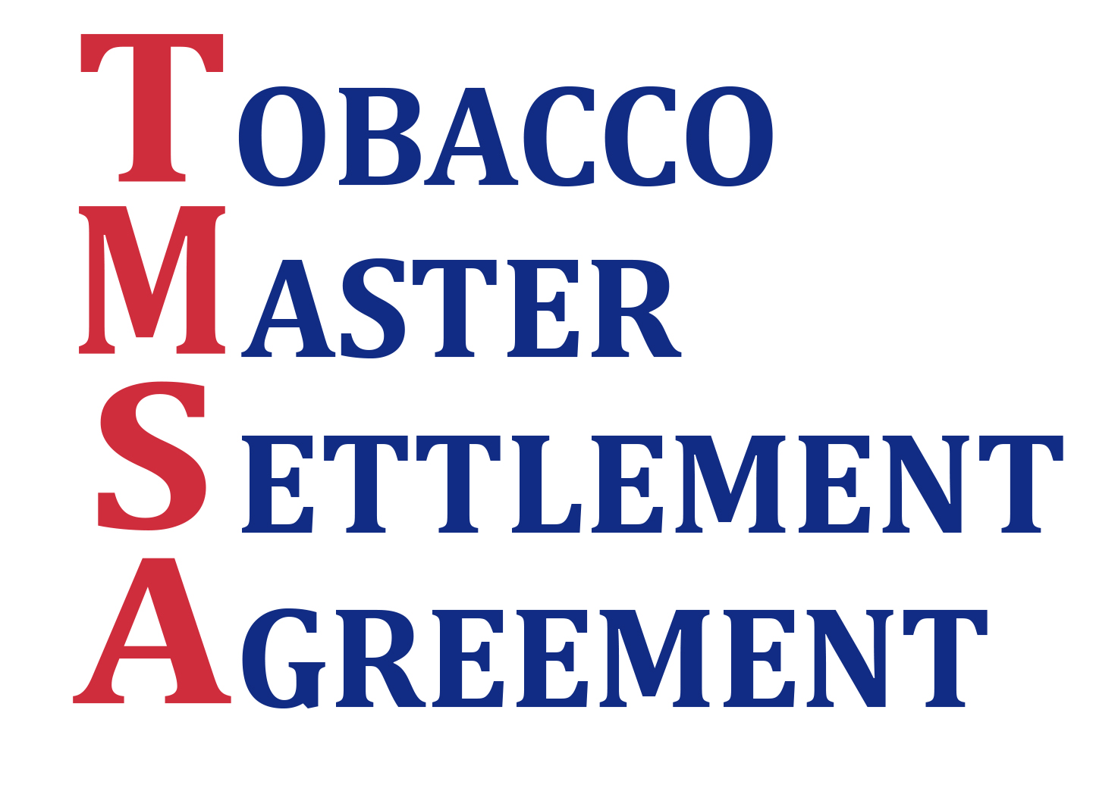

*\* Turn to back page for detailed breakdown of $120 million*

The monumental Tobacco Master Settlement Agreement between 46 states and the “Big 4” tobacco companies was finalized in 1998. Since then, not one penny of the $1 billion Oregon has received in settlement funds has gone towards tobacco prevention.

For the first time in a decade, we have the opportunity to invest Tobacco Master Settlement Agreement dollars toward the original purpose: ***compensating Oregon for taxpayer money spent on patients and family members with tobacco-related diseases and reducing tobacco use, with a focus on Oregon’s children.***

To fulfill the original intent of the Agreement and create long-term savings in Oregon’s health system, the TMSA Campaign recommends all **$120 million** **settlement funds* available in 2013-15** be allocated to health and wellness efforts.

* **$73 million for Oregon’s health transformation**

Investing in health transformation and prevention could leverage up to $120 million in matching federal dollars for CCOs and community partnerships to reduce tobacco use and improve health outcomes. This is a significant investment into improving the health, and reducing the health care costs, for Oregon.

* **$35 million for children’s health and wellness**

Focusing efforts on our children’s health and wellness will reduce chronic illness, improve mental and oral health, and integrate healthy behaviors by enhancing investment in physical education and school-based health centers.

* **$12 million to reduce smoking in Oregon**

According to a recent poll, 85% of Oregon voters favor dedicating *at least 10% of Oregon settlement money* to tobacco prevention programs. For every $1 spent on tobacco interventions, the State of Oregon realizes a $5 return on investment from reduced tobacco-related costs.

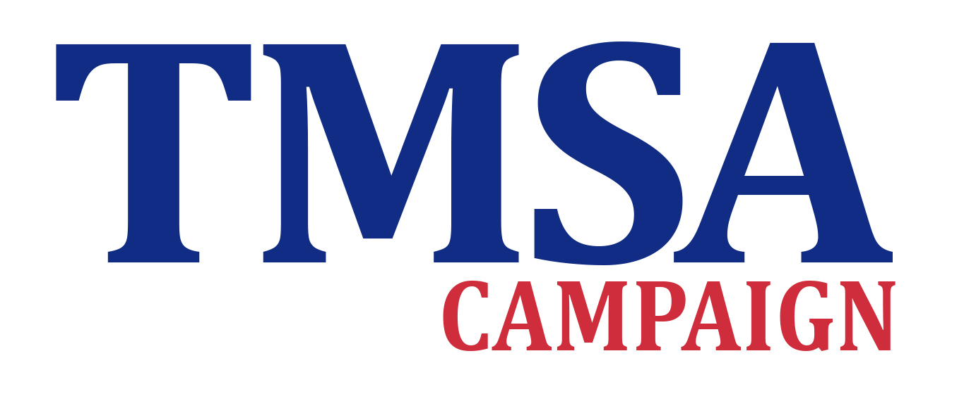

For more information, please contact:

Stephanie Tama-Sweet

503-828-8448

stephanie.tama-sweet@heart.org

Christel Allen

503-851-7473

christel@nwpublicaffairs.com

American Cancer Society Cancer Action Network

American Heart Association & American Stroke Association

American Lung Association in Oregon

Campaign for Tobacco-Free Kids

Coalition of Local Health Officials

Northwest Health Foundation

Oregon Medical Association

Oregon Nurses Association

Oregon Public Health Institute

Oregon School Based Health Care Network

Tobacco Free Coalition of Oregon, Inc. (TOFCO, Inc.)

Upstream Public Health

|  |  |  |
| --- | --- | --- |
| **Investing in Oregon’s health** | **Tobacco Master Settlement Agreement**  **Funds** | **Matching**  **Federal Funds** |
| Investment in Coordinated Care Organizations (CCOs) to implement evidence-based programs focused on prevention and reduction of chronic disease of the Medicaid population | $36.5 million | $60 million |
| Investment in community-based health initiatives to fund innovative strategies to combat chronic disease | $36.5 million | Up to $60 million |
| Investment in Tobacco Prevention and Education Program (TPEP) to improve health outcomes, drive down health care costs and save lives | $12 million |  |
| Investment in school-based health centers to address children’s chronic illness, mental health and oral health | $ 5 million |  |
| Investment in physical education in schools to promote healthy behaviors in our children | $30 million |  |
| **TOTAL** | **$120 million** | **Up to $120 million** |