**Power Hour Instructions: Your Voice Is Powerful!**

1. **11:00 am = call your lawmakers office**
2. **11:15 am = email your lawmaker**
3. **11:30 am = Tweet or go to Facebook with message to lawmaker**

**11:00am - Phone call:**

Call your lawmaker (phone number in your email) I timed the message below and it was under 2:00 minutes long! Use the same message to draft an email to your lawmaker. When transferring to the email format, feel free to expand on your cancer story, but your voice message must be concise. (Example Below)

Quick note – chances are that an assistant answers the phone, or you get a voicemail. Be ready to call an audible 😊.

**Example Power Hour phone message ready for editing with your personal story:**

**Step One - Introduction:** “My name is xx and I live in xx. I am calling as part of the American Cancer Society Cancer Action Network’s South Carolina Cancer Action Day: Suits and Sneakers. I know you are very busy but if you have a minute, I would like to leave a message for Rep. XX.

**Step Two – Your brief story** **(this is an example):** I am calling b*ecause I have seen far too many of my friends and family battle cancer. Losing someone far too soon is motivation enough for me to advocate for any cancer prevention method we can enact. You have the power to save lives in our great state by opposing House Bill 3681…. (into the bullet points below):*

**Step Three- your asks**

1. **I am asking Representative XX to oppose House Bill 3681 Tobacco Preemption and allow local communities to make decisions on how to best protect our children and youth from Big Tobacco. Do not make it easier for Big Tobacco to addict our children to their deadly products.**
2. **We would like to thank him/her for their continued support of funding cancer screenings in South Carolina. Screenings save lives and save the state and South Carolinians money.**

**I’m sure you are aware of the decline in cancer screening since COVID-19. We are asking for a one-time addition of $250,000 for The Center for Colon Cancer Prevention Network that would allow the program to:**

* **Increase direct screenings across the state for uninsured and underinsured**
* **Educate health care providers on changes of screening guidelines and encourage screenings to continue**

Let’s do everything we can to prevent any more families from going through what my family went through fighting cancer. **I will also follow up with an email message**.

**11:15am - Next, send an email:**

Email your above message to your Representative using the email we provide. Make sure to include the following:

* **Constituent of Rep. XX in subject line of your email**
* **CC Beth and I in your email –** [**marc.mazza@cancer.org**](mailto:marc.mazza@cancer.org) **&** [**beth.johnson@cancer.org**](mailto:beth.johnson@cancer.org)

**11:45am - Social media:**

Typically, we would ask you to bring a pair of shoes with you to the state house to represent a loved one who has been impacted by cancer. Since we are not together in Columbia, we are asking you to display your shoes “sneakers” on the steps of your home and use the photo on social media.

Below are sample posts and a photo:

**Facebook:** 9 out of 10 adult smokers first tried smoking by the age of 18, and each day in the US 1,600 kids under the age of 18 try their first cigarette. @MyRepresentative, do not make it easier for Big Tobacco to addict our children to their deadly products. Oppose H. 3681 Tobacco Preemption. @ACSCANSouthCarolina #NoTobaccoPreemptionSC #SCCancerActionDay

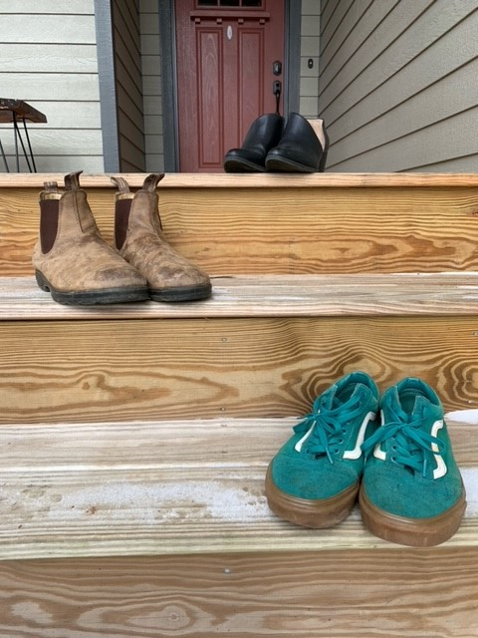

**Twitter:** I left a message for (@ tag your Representatives Twitter page) today as part of #SCCancerActionDay with @Acscansc. Pls support cancer prevention in SC. You have the power to make a difference. #NoTobaccoPreemptionSC

**Facebook**: I’m an advocate with @ACSCANSouthCarolina and I just left a voicemail with (@ tag your Representatives Facebook page) for #SCCancerActionDay and let them know why it’s so important to stop tobacco preemption in SC! Let him/her know why you think it’s important, too. #NoTobaccoPreemptionSC