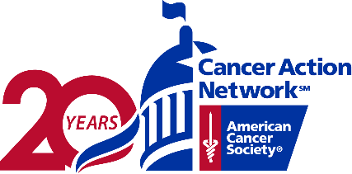
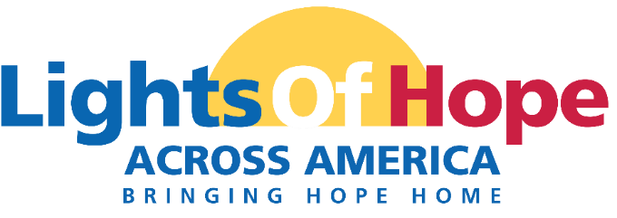

DATE
COMPANY
ADDRESS

Dear NAME,

On September 18, 2021 the American Cancer Society Cancer Action Network (ACS CAN) will host its 11th annual Lights of Hope event. This year will be truly special as we celebrate ACS CAN’s 20th anniversary.
Each Light of Hope honors loved ones who have survived cancer and remembers those we’ve lost. The displays in communities from coast to coast will send a clear and impactful message to lawmakers that fighting cancer must be a national priority – from increasing funding for lifesaving cancer research to ensuring that all Americans in all communities have access to quality, affordable cancer care. This event is very powerful and meaningful to all. Your support will help us light hope in our local community.

A look back at Lights of Hope 2020:
- ACS CAN volunteers displayed over 52,000 Lights of Hope across America shining at hundreds of home displays.
- We raised over $722,000.
- We had over 19,600 views of the Lights of Hope Across America Live broadcast.
- There were over 1,857 public posts on Twitter and Instagram for our social media wall using #LightsofHope.

We invite you and your organization to join us in the fight against cancer by sponsoring Lights of Hope locally. We are pleased to offer your organization the following benefits listed on the next few pages.

Please contact me if you have any questions or would like additional information.
Sincerely,

NAME
EMAIL
PERSONAL PAGE URL

