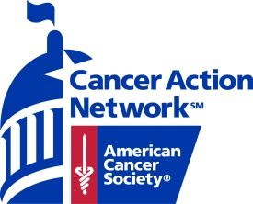

Dear Professor (Name),

I have received an invitation from the American Cancer Society Cancer Action Network to attend the State Day at the Capitol on (Date). State Days at the Capitol happen during the legislative session which is also during the school year, so I was hoping to receive your permission to accept this invitation.

State Day at the Capitol gives exceptional volunteers a rare opportunity to have a huge impact in the fight against cancer. By reaching out to our lawmakers, I have an opportunity to influence legislation that can help save lives.

The American Cancer Society Cancer Action Network (ACS CAN) is the nation’s leading cancer advocacy organization working everyday to make cancer issues a legislative priority. ACS CAN is holding our lawmakers accountable for their words and their actions. We are making sure our lawmakers not only talk about fighting cancer, but also take real steps to towards decreasing the number of people suffering and dying from cancer.

If you have any questions, please contact me or the local grassroots manager for ACS CAN at the number or email below.. Thank you for this opportunity. With passionate individuals devoted in the fight against cancer, we CAN see an end to cancer in my generation.

Signature
Student’s Name
Email
Phone number

Signature
Name | Title
American Cancer Society Cancer Action Network, Inc.
Address
City, State Zipcode
firstname.lastname@cancer.org
phone number
acscan.org

