Each year during Leadership Summit & Lobby Day (LS&LD) we capture hundreds of photos of our advocates in action in Washington, DC. With this year’s virtual event, we still want to document and share the impressive training, strategizing and advocating you’re doing on behalf of cancer patients …but from your own home! Please use this guide for taking and submitting photos throughout this year’s LS&LD!

DOs and DON’Ts for Taking Quality Photos Right at Home
DO
Show your ACS CAN pride! Advocates are strongly encouraged to include ACS CAN branding in photos. Include the ACS CAN logo any way you can: throw on your light blue polo, put on an ACS CAN hat, hold up your red, white & blue water bottle!
Display your individual style and how you’re joining LS&LD virtually from your living room, backyard or kitchen table.
Position yourself with bright, direct lighting on your face, looking straightforward into the camera.

Feel free to use “selfie” mode on your smartphone or with your computer’s webcam or ask a member of your household to snap a pic of you.

DON’T
Wear or display logos for Cancer Votes, Relay For Life or Making Strides Against Breast Cancer.

Wear busy patterns or pose in front of distracting backgrounds.

Position yourself with a bright light (like a window) behind you.

Worry about being perfect. Authentic photos are the best photos.

Photos Catching Advocates in Action!
A little distance helps frame the shot!
Selfies are fun!
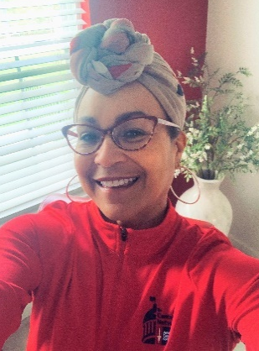
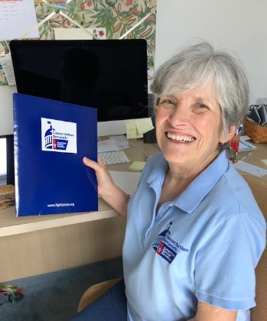
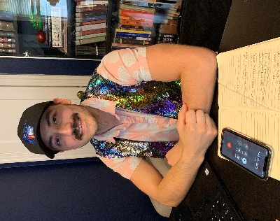
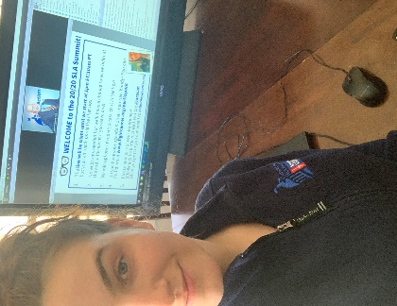
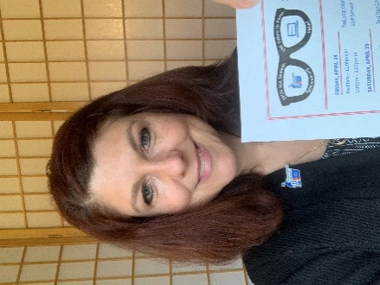

Take a great shot by: being in focus, featuring your face & ACS CAN logos, and showing your personality!

Please Share Your Photos with ACS CAN!

Option 1: If you share your photos or videos on social media – Facebook, Instagram, Twitter, yes! – be sure to use the hashtag #CancerLobbyDay or #LightsOfHope. This way, @acscan staff can find and save them.
Option 2: Upload your photos right on fightcancer.org and include a caption.

