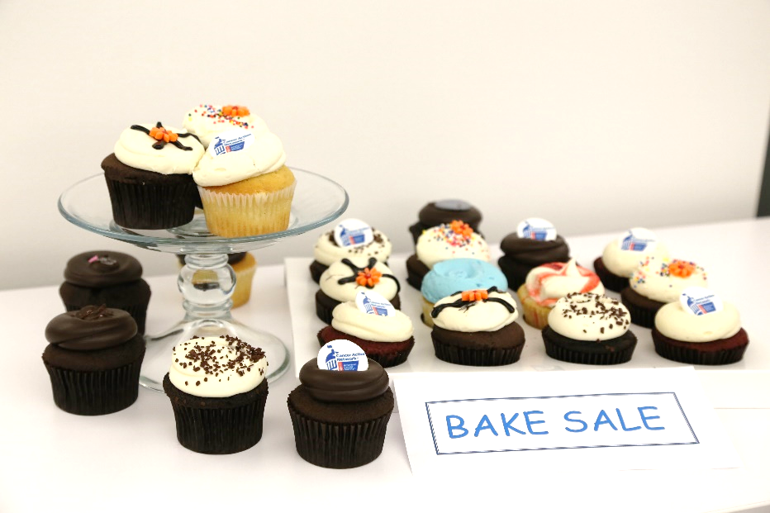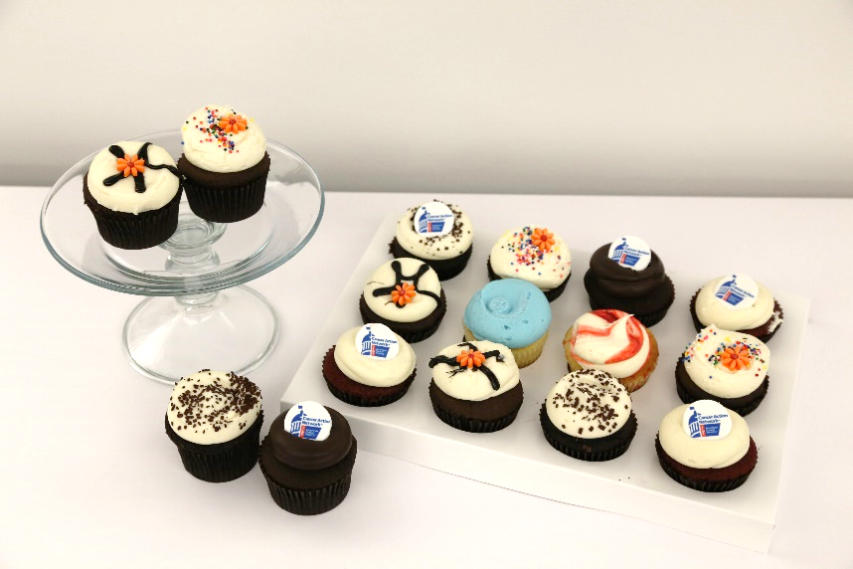

EVENT INTRO

-------------------------------------

**Bake sale**

EVENT SUB-TITLE

-------------------------------------

DATE

TIME

LOCATION

Address, City, St Zip Code

To replace any placeholder text (such as this), just click it and start typing.

We think this beautiful flyer makes a great statement just as it is. But if you’d like to make it your own, explore different fonts and colors on the Design tab.

Double click in the header to change the background image or object.

Proceeds will benefit the American Cancer Society Cancer Action Network