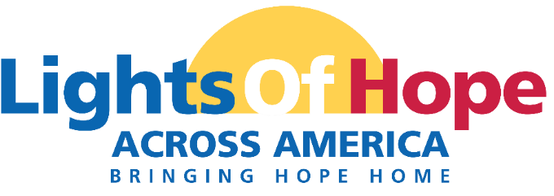

DATE
COMPANY
ADDRESS

Dear NAME,

In September 2023, the American Cancer Society Cancer Action Network (ACS CAN) will host its 13th annual Lights of Hope event.

Each Light of Hope represents a loved one’s cancer story—a survivor, someone in treatment, someone who passed from cancer, or someone who served as a caregiver. The displays in communities across America, including one on the National Mall in Washington D.C. will send a clear and impactful message to lawmakers that fighting cancer must be a national priority – from increasing funding for lifesaving cancer research to ensuring that all Americans in all communities have access to quality, affordable cancer care.

This event is very powerful and meaningful to all. Your support will help us light hope in our local community.

A look back at Lights of Hope 2022:
- We displayed over 65,000 Lights of Hope across America shinning bright at hundreds of at home displays, including the DC Hope Walk display.
- We raised over $876,836
- 1,857 public posts on Twitter and Instagram for our social media wall

We invite you and your organization to join us in the fight against cancer by sponsoring Lights of Hope locally. We are pleased to offer your organization the following benefits listed on the next few pages.

Please contact me if you have any questions or would like additional information.
Sincerely,

NAME
EMAIL
PERSONAL PAGE URL

