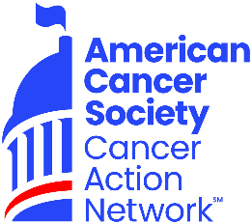

Dear NAME,

Hello! My name is ENTER NAME, and I am a volunteer for the American Cancer Society Cancer Action Network (ACS CAN). I started volunteering in YEAR, to help make the fight against cancer a national priority, after seeing many friends and family members fight this horrible disease.
I am writing today to request your support for ACS CAN’s 13th annual Lights of Hope event in September. Lights of Hope bags dedicated to loved ones who have been touched by cancer will be displayed in local communities from coast to coast.

How does it work? Well, with a minimum of a $10 donation, individuals can dedicate a Light of Hope in honor of a loved one. But with our sponsorship opportunities, you can shine an even bigger light in our local community, with opportunities to have sponsorship lawn signs, be recognized by ACS CAN nationally, and more. I’ll also recognize your organization on my Lights of Hope page, and on the ACS CAN <STATE> Facebook/Twitter/Instagram pages. You and your staff can decorate all of your own Lights of Hope bags, or you can provide names of your loved ones and I can happily decorate them for you.

I am excited to be a part of this incredible event again and I hope you will join me honoring friends and family who have been touched by cancer. You can help us send a visible reminder to Congress that they need to make fighting cancer a legislative priority.

To become a sponsor, please email me acknowledging your sponsorship level commitment. Then, you can either make the donation electronically at PERSONAL PAGE URL or you can write a check made out to ACS CAN and I will provide instructions on where to mail the check.
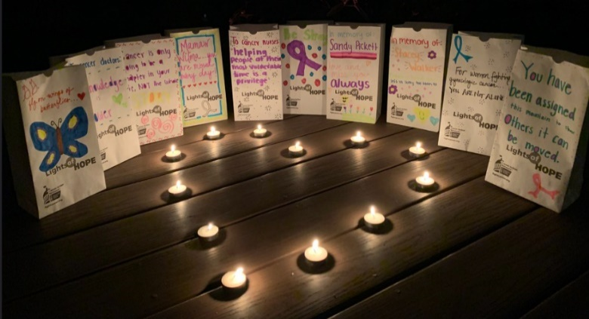
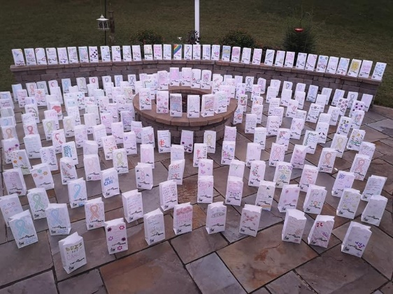

Please do not hesitate to reach out to me with any questions:

Sincerely,

Name:
Email:

